|  |  |
| --- | --- |
|  | **FPT ACADEMY INTERNATIONAL**  **FPT – APTECH COMPUTER EDUCATION** |

**Centre Name: ACE-HCMC-2-FPT.**

**Address: 590 Cach Mang Thang 8, District 3, Ho Chi Minh City, Viet Nam.**

**Insurance Online**

**Design Document**

|  |  |  |
| --- | --- | --- |
| **Supervisor:** | Mr. Hoang Duc Quang | |
| **Semester:** | 3 | |
| **Batch No:** | T1.2011.M0 | |
| **Group No:** | 3 | |
| **Order:** | **Full name** | **Roll No.** |
| 1. | Do Tran Long | Student1287966 |
| 2. | Do Thanh Nam | Student1286087 |
| 3. | Le Ngan Tam | Student1288146 |
| 4. | Dinh Ngoc Minh Hieu | Student1285592 |

April 2022

**This is to certify that**

**Mr.** Do Tran Long

**Mr.** Do Thanh Nam

**Ms.** Le Ngan Tam

**Mr.** Dinh Ngoc Minh Hieu

**have successfully designed & developed:**

eProject: Insurance Online

**Submitted by:**

Mr. Hoang Duc Quang

**Date of issue:** April 29 2022

**Authorized Signature:**

# Table of Contents

Table of Contents I-2

REVIEW 1 I-3

I. Acknowledgement I-4

II. Problem Definition: I-5

III. Requirement Specification I-6

1. Customer's Requirement Specifications I-6

3.1. Website: I-7

3.2. Admin: I-8

2. Functional Requirement Specifications I-8

3.1. Function of Customer: I-8

User can: I-8

3.2. Function of Admin: I-8

Admin can: I-8

3. System Requirement Specifications I-9

3.1. Server requirements: I-9

3.2. Client requirements: I-9

3.3. Development Software: I-10

3.4. Technology: I-10

TASK SHEET REVIEW 1 I-11

REVIEW 2 I-12

I. Architecture & Design of the Project I-13

1. Presentation Tier: I-14

2. Business Logic Tier: I-14

3. Data Access Tier: I-14

III. Use Case Diagram I-36

**1.** **Admin Use Case** I-15

**2.** **Customer Use Case**  I-39

II. Algorithms – Data Flowchart I-44

1. Symbol generates: I-44

2. Main data flowchart (For Customer) I-45

3. Login process (For admin) I-45

4. Logout process (For admin) I-46

5. Update Customer’s Profile process (For Customer) I-46

6. Insert Category(For admin) I-46

7. Update Category (For admin ) I-46

8. Delete category (For admin ) I-46

9. Insert Policy (For admin) I-47

10. Update Policy (For admin) I-47

11. Delete Policy (For admin) I-47

12. Insert FAQs (For admin) I-47

13. Update FAQs (For admin) I-47

14. delete FAQs (For admin) I-48

15. Insert Reply(For admin) I-48

16. Update reply (For admin) I-48

17. Delete Reply (For admin ) I-48

18. Update Feedback(For admin) I-48

19. delete feedback (For admin) I-48

TASK SHEET REVIEW 2 I-49

REVIEW 3 I-50

I. DATABASE DESIGN I-51  
II. DATABASE StrucTURE I-51

III. GUI DESIGN Front-end(Customer) II-52

IV. GUI DESIGN Back-end(Admin) II-52

TASK SHEET REVIEW 3 II-53

REVIEW 1

# Acknowledgement

First and foremost, we would like to express the deepest appreciation to our admirable instructor – Mr.Hoang Duc Quang. During the time of the project, he continually and convincingly conveyed a spirit of adventure in regard to research and scholarship, and an excitement in regard to teaching. Without his guidance and persistent help this dissertation would not have been possible. Therefore, once again, we truly value your dedication and guidance, Mr. Sinh.

Next, it would have been impossible to carry out and complete this project without the collaboration among our team members. Although we have gone through many obstacles during the project implementation, eventually we gained what we aimed at by our hard work, our strong commitment and of course, our brotherhood.

Finally, thanks to Aptech’s eProject team, we had a golden opportunity to apply what we have learnt into reality and gain hands-on experience which is essential for our future career.

.

1. **Problem Definition:**

Insurance is a contract for payment of a sum of money to the person assured on the happening of the event insured against. Usually the contract provides for the payment of an amount on the date of maturity or at specified dates at periodic intervals or at unfortunate death, if it occurs earlier. Among other things, the contract also provides for the payment of premium periodically to the Corporation by the assured. Insurance is universally acknowledged to be an institution which eliminates `risk', substituting certainty for uncertainty and comes to the timely aid of the family in the unfortunate event of death of the breadwinner.

# Project Requirements:

This software provides four types of Insurance services, which includes Life Insurance, medical Insurance, Motor Insurance. Home Insurance,

Presently this project follows Internet mode i.e. the details can be viewed and updated by the officials of the company.

Online Insurance Service has the following features:

1). A User can view the details of various policies and schemes offered by the Insurance Company.   
2).**New Users** can register with the site so that he can get information online.  
3).An existing policyholder can view his policy details and calculate the premium.  
4).The web site provides information about the new strategies and subsidiary  
schemes of the company.   
5).Provides loan facility for policyholders and online payments.

Calculation of the premium is to be done Term plan taken by the person.

# Insurance includes

**Life Insurance**: Life insurance is a plan which provides protection to the insured and his family with financial coverage in case of any mishaps. To avail the benefits of life insurance policy, the policy holder has to pay a monthly premium to the insurer for a certain period of time.

**Medical Insurance:** Under this type of health care cover, medical expenses are covered. When an insured person needs medical treatment due to illness or accident, the insurance agent provides coverage for his expenses such as doctor fees, hospital fees, medicine cost and other related bills.

**Motor insurance:** Under this type of plan which provides protection against the auto-mobile the user owns.

**Home Insurance:** The most popular among the **6 types of insurance** is the home insurance that provides compensation for any mishaps that occurs on your home. Coverage is provided according to the policy and premium paid by the homeowner. There are various types of home insurance plans that you can choose from to suit your needs.

# Requirement Specification

## Customer's Requirement Specifications

### 1.1 Website:

The web page contains all the types of the templates in the categorized manner like Life Insurance, Medical Insurance, Motor insurance, Home Insurance.

Home Page ill be well designed and formatted with all the navigational Motor insurance links, proper header section and footer section of the web page, Links for login in the site.

It should contain links such as HOME: Life Insurance, Medical Insurance, Motor Insurance and Home Insurance, FEEDBACK, LOGIN (ADMIN and Customer), Register.

### 1.2 Admin:

**Requirements:**

### Admin can check the List of the registered users and their payment details

### Admin can check of the insurance being ordered and the updating the status

### Admin can check the feedbacks entered by the customer.

### Admin can add, delete, repair insurance services.

### Admin can change or update easily the design and the content of the Contact us

### 1.3 Customer.

**Requirements:**

* Customer can view the details of various policies and schemes offered by the Insurance Company.
* New Customer can register with the site so that he can get information online.
* Customers can manage personal information, edit the insurance service package.
* Customers can add insurance service packages.
* Customer can view his policy details and calculate the Premium.
* Customer will be provided information about the new strategies and Subsidiary schemes of the company
* Customer are provided by the company loan facility for policyholders and online payments.
* Customers can send feedback

## Functional Requirement Specifications

### 2.1 Function of Customer:

Customer can register.

Customer can login

Customer can logout

Customer can change password

Customer can update personal information

Customer can search insurance

Customer can view Health insurance policies

Customer can view Life insurance policies

Customer can view Motor insurance policies

Customer can view Home insurance policies

Customer can view FAQs Health insurance

Customer can view FAQs Life insurance

Customer can view FAQs Motor insurance

Customer can view FAQs Home insurance

Customer can view insurance history

Customer can send feedback.

Customer can payment

Customer can view bill

### Function of Admin:

Admin can login.

Admin can logout

Admin can change password.

Admin can view category.

Admin can add category.

Admin can delete category.

Admin can update category

Admin can view customer.

Admin can disable customer.

Admin can enable customer.

Admin can view feedback.

Admin can reply feedback.

Admin can delete feedback.

Admin can view policy.

Admin can add policy.

Admin can delete policy.

Admin can update policy.

Admin can view payment.

Admin update view payment.

Admin can view FAQs.

Admin can add FAQs.

Admin can delete FAQs.

Admin can update FAQs

## System Requirement Specifications

### Server requirements:

#### Hardware:

|  |  |
| --- | --- |
| Component | Requirement |
| CPU | Processor type:  Pentium IV-compatible processor or faster  Processor speed:  Recommended: 2.0 GHz or faster |
| OS | Microsoft Windows XP or higher with IIS |
| Memory (RAM) | RAM:  Minimum: 512 MB  Recommended: 2 GB or more |
| Hard Drive | Free space:  Minimum: 200 MB  Recommended: 50 GB or more  Maximum: Operating system maximum |

#### Software:

|  |  |
| --- | --- |
| Component | Requirement |
| ASP.NET Core | Version .NET Core 6.0 |
| RDBMS | SQL SERVER |

### Client requirements:

#### Hardware:

|  |  |
| --- | --- |
| Component | Requirement |
| CPU | Processor type:  Pentium III-compatible processor or faster  Processor speed:  Recommended: 1.0 GHz or faster |
| OS | All OS(Window ,Linux ,Android ,Mac OS …) |
| Memory (RAM) | RAM:  Minimum: 512 MB  Recommended: 1 GB or more  Maximum: Operating system maximum |
| Hard Drive | Free space:  Minimum: 10 MB |

#### Software:

|  |  |
| --- | --- |
| Component | Requirement |
| Web Browser | Microsoft Edge, Firefox, CocCoc ,Chrome or Higher….. |

### Development Software:

Microsoft Visual Studio 2022.

### Technology:

ASP.Net Core 6.0

Entity Framework Core 6.0.5

# TASK SHEET REVIEW 1

|  |  |  |  |  |  |  |  |
| --- | --- | --- | --- | --- | --- | --- | --- |
| **Project Ref. No.:**  **eP/Advertisement** **Portal Management** **System/01** | | **Project Title:** | **Activity Plan** **Prepared** **By:** | **Date of Preparation of Activity Plan:** | | | |
| **Sr.No.** | **Task** | **Actual Start** **Date** | **Actual** **Days** | **Team** **Mate** **Names** | **Status** |
| 1 | Acknowledgement | Insurance Online | Do Thanh Nam |  | 1 | All member | Completed |
| 2 | Problem Definition |  | 1 | All member | Completed |
| 3 | Requirement Specification |  | 1 | All member | Completed |
| 4 | Task sheet review |  | 1 | All member | Completed |

|  |  |
| --- | --- |
| **Date: 09/05/2020** | |
| Signature of Instructor: | Signature of Team Leader:  **Do Thanh Nam** |

REVIEW 2

1. **Architecture & Design of the Project**

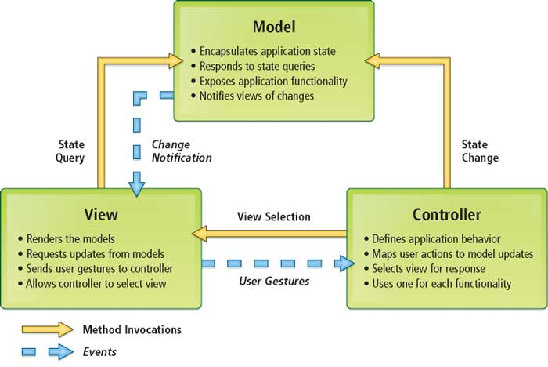

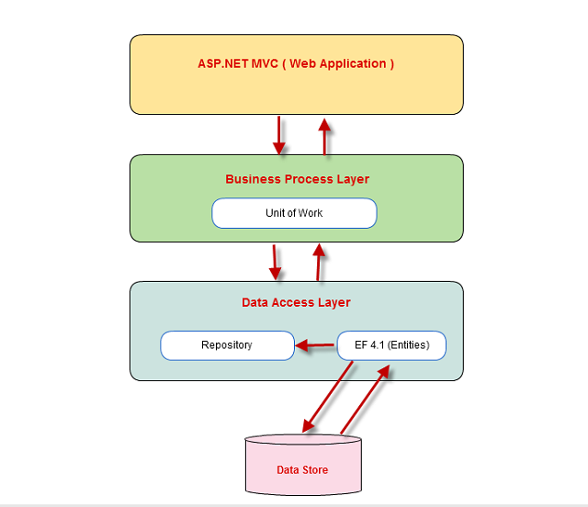

## Presentation Tier:

This is the tier in which the users interact with application. Presentation Tier contains Model, View, Controller used to receive a request and response to User.

Technology: ASP.NET MVC5, Razor, HTML, CSS, JavaScript, Ajax, JQUERY, Bootstrap

## Business Logic Tier:

Is mainly working as the bridge between Data Tier and Presentation Tier. All the Data passes through the Business Tier before passing to the Presentation Tier.

Technology: OOP, ASP.NET

## Data Access Tier:

This is basically the server which stores all the application’s data. Data tier contents Database Tables, Database Views and other means of storing Application’s data.

Technology: SQL Server, Entity Framework

1. **Use Case Diagram**
   * + 1. **Admin Use Case**

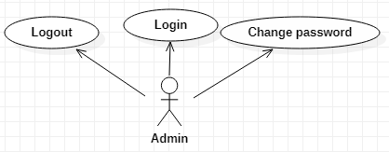

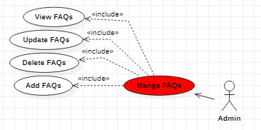

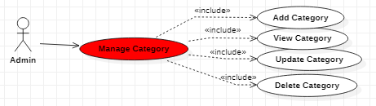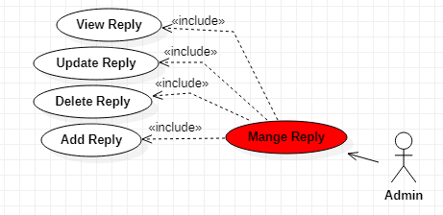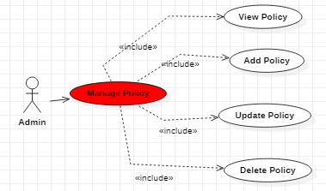

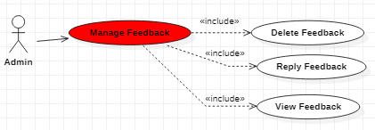

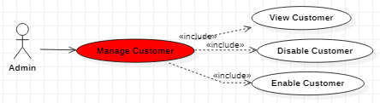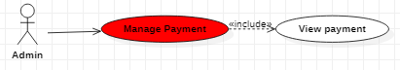

**1.1 Login**

|  |  |
| --- | --- |
| **Author** | Dinh Ngoc Minh Hieu |
| **Use Case Name** | Login |
| **Actors** | Administrator |
| **Description** | Administrator wants to login to Admin page. |
| **Requirements** | Actor provides username and password |
| **Pre-conditions** |  |
| **Post-conditions** | Success: Administrator logged in to website. Fail: Refill information |
| **Basic flow** | Actor Actions:  1. Actor typeusername and password, then click “Login” button. | System Responses: 2. System redirects to Login page and displays Login form with the following control: - ‘UserName’ text field - ‘Password’ text field - ‘Login’ button 3. System checks the information  4. System redirects to Admin Home page. |
| **Alternative flow** |  |  |
| **Exception** | Actor Actions: 1. Actor lefts ‘UserName’ text field blank.  2.Actor lefts ‘Password’ text field blank. | System Responses:  System show message: - “Wrong email or password |

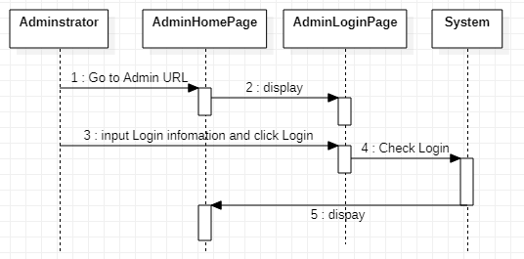

**1.2 Log out**

|  |  |
| --- | --- |
| **Author** | Dinh Ngoc Minh Hieu |
| **Use Case Name** | Logout |
| **Actors** | Administrator |
| **Description** | Administrator wants to logout to Admin page. |
| **Requirements** |  |
| **Pre-conditions** |  |
| **Post-conditions** |  |
| **Basic flow** | Actor action: 1. Visitor click “Logout” link | System Responses: 2. System delete admin session data |
| **Alternative flow** |  |  |
| **Exception** | Actor Actions:  Actor lefts ‘UserName’ text field blank. Actor lefts ‘Password’ text field blank. | System Responses: System displays message to Guest : - ‘UserName’ cannot be blank’. - ‘Password cannot be blank’. |

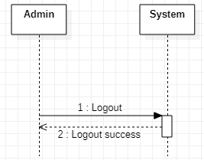

**1.3 Change Password**

|  |  |
| --- | --- |
| **Author** | Dinh Ngoc Minh Hieu |
| **Use Case Name** | Change Password |
| **Actors** | Administrator |
| **Description** | Administrator wants to Change to Admin page. |
| **Requirements** | Actor provides Username and Password |
| **Pre-conditions** | Actor has logged in as Administrator |
| **Post-conditions** | Success: The password of Administrator has changed. |
| **Basic flow** | Actor actions: 1. From ‘Admin’ page, actor clicks on to the ‘Change Password’ button.  3. Actor clicks on to ‘Save’ button to finish adding. | System response: 2. System redirects to ‘Change Password’ page and display form with the following controls: ‘Old Password’ textfield. ‘New Password’ textfield. ‘Confirm New Password’ textfield. ‘Save’ button. 4. System checks input information. 5. System adds new Administrator into the database. |
| **Alternative flow** |  |  |
| **Exception** | Actor Actions: 1. Actor lefts ‘UserName’ text field blank. 2. Actor lefts ‘Password’ text field blank. | System Responses: System displays message to Guest : - ‘UserName’ cannot be blank’. - ‘Password cannot be blank’. |

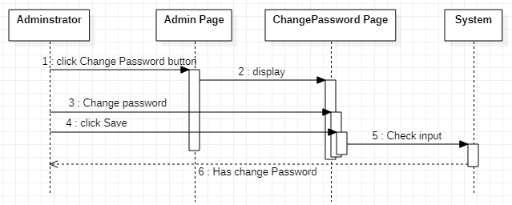

**1.4 Manage Policy**

**1.4.1 View List Policy**

|  |  |
| --- | --- |
| **Author** | Dinh Ngoc Minh Hieu |
| **Use Case Name** | View List Policy |
| **Actors** | Administrator |
| **Description** | Administrator wants to View list Policy page. |
| **Requirements** |  |
| **Pre-conditions** | Actor has logged in as Administrator |
| **Post-conditions** | Success: List of Policy show successful |
| **Basic flow** | Actor Actions: 1. Actor clicks ‘Manage Policy “button on Admin page | System Responses: 2. System redirects to View List Policy page and displays form for Actor : -‘PolicyID’ label -“Name’ label -‘Description’ label -‘Created_at label -‘Update_at’ label -‘Insert’ button -‘Update’ button -‘Delete’ button |
| **Alternative flow** | Actor Actions: -Actor clicks ‘Insert’ button on View List Policy page -Actor clicks ‘Update’ button on View List Policy page  -Actor clicks “Delete” button on View List Policy page | System Responses:  -System redirects to Insert Policy page  -System redirects to Update Policy page  -System redirects to Delete Policy page |
| **Exception** |  |  |

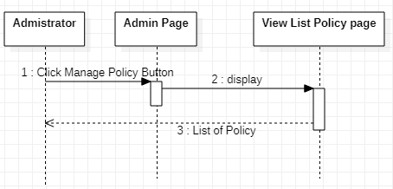

**1.4.2 Insert Policy**

|  |  |
| --- | --- |
| **Author** | Dinh Ngoc Minh Hieu |
| **Use Case Name** | Add policy |
| **Actors** | Administrator |
| **Description** | Administrator wants to Add new Policy |
| **Requirements** |  |
| **Pre-conditions** | Actor has logged in as Administrator |
| **Post-conditions** | Success: Add Policy successful Fail: Refill information |
| **Basic flow** | Actor Actions: 1. Actor clicks ‘Add’ button on View list of Policy page  3.Actor inputs property type information:  -Provide the Policy’ name in ‘Name’ text field. -Provide the Policy’ Description in ‘Description’ text field.  -Provide the Policy’ Created_at in Created_at text field.  -Provide the Policy’ Update_at in Update_at text field  5. Actor click ‘Add’ button | System Responses: 2. System redirects to View List Policy page and displays form for Actor to input information with the following control :  -“Name’ text feild -‘Description’ text feild -‘Created_at text feild -‘Update_at’ text feild - Add button -Cancel button  4. System checks information input  6. System add bank into database then display message ‘Your Policy has been add successful |
| **Alternative flow** | Actor click ‘Cancel’ button | System redirects to View List Policy page. |
| **Exception** | Actor Actions:  -Actor left ‘Name’ text field blank  -Actor left ‘Description’ text field blank  -Actor left ‘Created_at’ text field blank  -Actor left ‘Update_at’ text field blank | System Responses:  -Name can’t be blank and correct format  -Description can’t be blank and correct format  -Created_at can’t be blank and correct format  -Update_at can’t be blank and correct format |

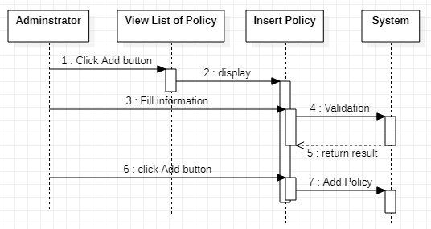

**1.4.3 Update Policy**

|  |  |
| --- | --- |
| **Author** | Dinh Ngoc Minh Hieu |
| **Use Case Name** | Update policy |
| **Actors** | Administrator |
| **Description** | Administrator wants to Update Policy |
| **Requirements** | Administrator must be choose Policy to update |
| **Pre-conditions** | Actor has logged in as Administrator |
| **Post-conditions** | Success: Update Policy successful Fail: Refill information |
| **Basic flow** | Actor Actions: 1. Actor clicks ‘Insert’ button on View list of Policy page  3.Actor inputs property type information:  -Provide the Policy’ name in ‘Name’ text field. -Provide the Policy’ Description in ‘Description’ text field.  -Provide the Policy’ Created_at in Created_at text field.  -Provide the Policy’ Update_at in Update_at text field  5. Actor click “Update’ button | System Responses: 2. System redirects to this page and displays form for Actor to input information with the following control :  -“Name’ text feild -‘Description’ text feild -‘Created_at text feild -‘Update_at’ text feild - Update button -Cancel button  4. System checks information input  6. System add bank into database then display message ‘Your Policy has been update successful |
| **Alternative flow** | Actor click ‘Cancel’ button | System redirects to View List Policy page. |
| **Exception** | Actor Actions:  -Actor left ‘Name’ text field blank  -Actor left ‘Description’ text field blank  -Actor left ‘Created_at’ text field blank  -Actor left ‘Update_at’ text field blank | System Responses:  -Name can’t be blank and correct format  -Description can’t be blank and correct format  -Created_at can’t be blank and correct format  -Update_at can’t be blank and correct format |

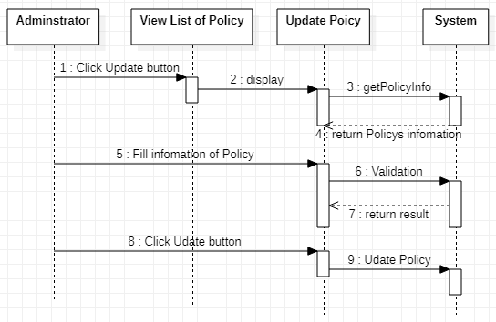

**1.4.4 Delete Policy**

|  |  |
| --- | --- |
| **Author** | Dinh Ngoc Minh Hieu |
| **Use Case Name** | Delete policy |
| **Actors** | Administrator |
| **Description** | Administrator wants to Delete Policy |
| **Requirements** | Administrator must be choose Policy to delete |
| **Pre-conditions** | Actor has logged in as Administrator |
| **Post-conditions** | Success: Delete Policy successful Fail: Error page show |
| **Basic flow** | Actor Actions: 1. Actor clicks ‘Delete’ button on View list of Policy page  3. Actor clicks Yes button on popup message | System Responses: 2. System show popup message :”Do you want to remove this bank : ” + Policy’s name. With Yes and No button  4. System delete bank from database then display message ‘Your Policy has been deletesuccessful’ |
| **Alternative flow** | Actor Actions: Actor clicks No button on popup message | System Responses: System returns to current page |
| **Exception** |  |  |

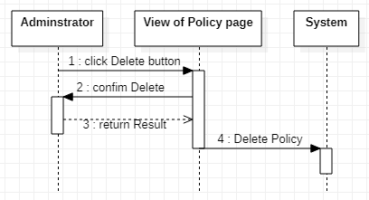

**1.5 Manage FAQs**

**1.5.1 View List FAQs**

|  |  |
| --- | --- |
| **Author** | Dinh Ngoc Minh Hieu |
| **Use Case Name** | View List FAQs |
| **Actors** | Administrator |
| **Description** | Administrator wants to View list FAQs page. |
| **Requirements** |  |
| **Pre-conditions** | Actor has logged in as Administrator |
| **Post-conditions** | Success: List of FAQs show successful |
| **Basic flow** | Actor Actions: 1. Actor clicks ‘Manage FAQs “button on Admin page | System Responses: 2. System redirects to View List FAQs page and displays form for Actor : -‘FAQsID’ label -“Question” label -‘Created_at label -‘Update_at’ label -‘Insert’ button -‘Update’ button -‘Delete’ button |
| **Alternative flow** | Actor Actions: -Actor clicks ‘Insert’ button on View List FAQs page -Actor clicks ‘Update’ button on View List FAQs page  -Actor clicks “Delete” button on View List FAQs page | System Responses:  -System redirects to Insert FAQs page  -System redirects to Update FAQs page  -System redirects to Delete FAQs page |
| **Exception** |  |  |

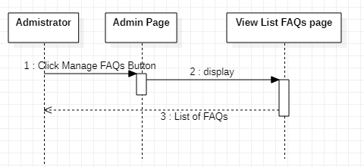

**1.5.2 Insert FAQs**

|  |  |
| --- | --- |
| **Author** | Dinh Ngoc Minh Hieu |
| **Use Case Name** | Add FAQs |
| **Actors** | Administrator |
| **Description** | Administrator wants to Add new FAQs |
| **Requirements** |  |
| **Pre-conditions** | Actor has logged in as Administrator |
| **Post-conditions** | Success: Add FAQs successful Fail: Refill information |
| **Basic flow** | Actor Actions: 1. Actor clicks ‘Add’ button on View list of FAQs page  3.Actor inputs property type information:  -Provide the FAQs’ question in “Question’ text field.  -Provide the FAQs’ Created_at in Created_at text field.  -Provide the FAQs’ Update_at in Update_at text field  5. Actor click ‘Add’ button | System Responses: 2. System redirects to View List FAQs page and displays form for Actor to input information with the following control :  -“Question’ text feild  -‘Created_at text feild -‘Update_at’ text feild - Add button -Cancel button  4. System checks information input  6. System add bank into database then display message ‘Your FAQs has been add successful |
| **Alternative flow** | Actor click ‘Cancel’ button | System redirects to View List FAQs page. |
| **Exception** | Actor Actions:  -Actor left ‘Question’text field blank  -Actor left ‘Created_at’ text field blank  -Actor left ‘Update_at’ text field blank | System Responses:  -Question can’t be blank and correct format  -Created_at can’t be blank and correct format  -Update_at can’t be blank and correct format |

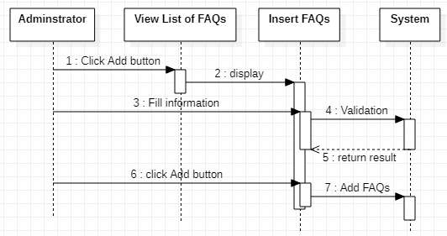

**1.5.3 Update FAQs**

|  |  |
| --- | --- |
| **Author** | Dinh Ngoc Minh Hieu |
| **Use Case Name** | Update FAQs |
| **Actors** | Administrator |
| **Description** | Administrator wants to Update new FAQs |
| **Requirements** | Administrator must be choose FAQs to Update |
| **Pre-conditions** | Actor has logged in as Administrator |
| **Post-conditions** | Success: Add FAQs successful Fail: Refill information |
| **Basic flow** | Actor Actions: 1. Actor clicks ‘Update’ button on View list of FAQs page  3.Actor inputs property type information:  -Provide the FAQs’ question in “Question’ text field.  -Provide the FAQs’ Created_at in Created_at text field.  -Provide the FAQs’ Update_at in Update_at text field  5. Actor click ‘Add’ button | System Responses: 2. System redirects to View List FAQs page and displays form for Actor to input information with the following control :  -“Question’ text feild  -‘Created_at text feild -‘Update_at’ text feild - Add button -Cancel button  4. System checks information input  6. System add bank into database then display message ‘Your FAQs has been update successful |
| **Alternative flow** | Actor click ‘Cancel’ button | System redirects to View List FAQs page. |
| **Exception** | Actor Actions:  -Actor left ‘Question’text field blank  -Actor left ‘Created_at’ text field blank  -Actor left ‘Update_at’ text field blank | System Responses:  -Question can’t be blank and correct format  -Created_at can’t be blank and correct format  -Update_at can’t be blank and correct format |

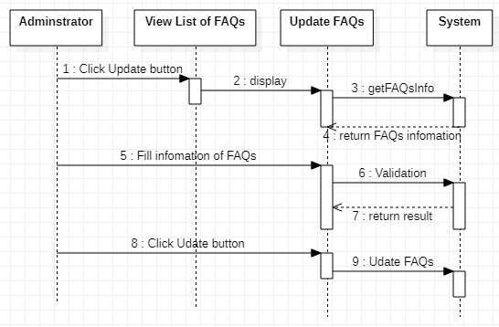

**1.5.4 Delete FAQs**

|  |  |
| --- | --- |
| **Author** | Dinh Ngoc Minh Hieu |
| **Use Case Name** | Delete FAQs |
| **Actors** | Administrator |
| **Description** | Administrator wants to Delete FAQs |
| **Requirements** | Administrator must be choose FAQs to delete |
| **Pre-conditions** | Actor has logged in as Administrator |
| **Post-conditions** | Success: Delete FAQs successful Fail: Error page show |
| **Basic flow** | Actor Actions: 1. Actor clicks ‘Delete’ button on View list of FAQs page  3. Actor clicks Yes button on popup message | System Responses: 2. System show popup message :”Do you want to remove this bank : ” + FAQs’s name. With Yes and No button  4. System delete bank from database then display message ‘Your FAQs has been delete successful’ |
| **Alternative flow** | Actor Actions: Actor clicks No button on popup message | System Responses: System returns to current page |
| **Exception** |  |  |

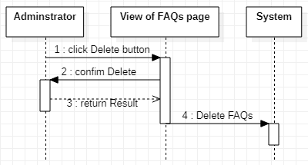

**1.6 Manage Category**

**1.6.1 View Category**

|  |  |
| --- | --- |
| **Author** | Dinh Ngoc Minh Hieu |
| **Use Case Name** | View List Category |
| **Actors** | Administrator |
| **Description** | Administrator wants to View list Category page. |
| **Requirements** |  |
| **Pre-conditions** | Actor has logged in as Administrator |
| **Post-conditions** | Success: List of Category show successful |
| **Basic flow** | Actor Actions: 1. Actor clicks ‘Manage Category “button on Admin page | System Responses: 2. System redirects to View List Category page and displays form for Actor : -‘CategoryID’ label -“Name” label -‘Created_at label -‘Update_at’ label -‘Description’ label -‘Insert’ button -‘Update’ button -‘Delete’ button |
| **Alternative flow** | Actor Actions: -Actor clicks ‘Insert’ button on View List Category page -Actor clicks ‘Update’ button on View List Category page  -Actor clicks “Delete” button on View List Category page | System Responses:  -System redirects to Insert Category page  -System redirects to Update Category page  -System redirects to Delete Category page |
| **Exception** |  |  |

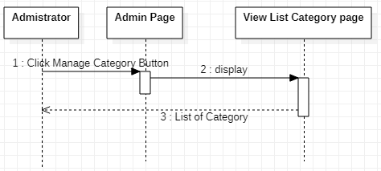

**1.6.2 Insert Category**

|  |  |
| --- | --- |
| **Author** | Dinh Ngoc Minh Hieu |
| **Use Case Name** | Add Category |
| **Actors** | Administrator |
| **Description** | Administrator wants to Add new Category |
| **Requirements** |  |
| **Pre-conditions** | Actor has logged in as Administrator |
| **Post-conditions** | Success: Add Category successful Fail: Refill information |
| **Basic flow** | Actor Actions: 1. Actor clicks ‘Add’ button on View list of Category page  3.Actor inputs property type information:  -Provide the Category’ Name in “Name’ text field.  -Provide the Category’ Description in “Name’ text field.  -Provide the Category’ Created_at in Created_at text field.  -Provide the Category’ Update_at in Update_at text field  5. Actor click ‘Add’ button | System Responses: 2. System redirects to View List Category page and displays form for Actor to input information with the following control :  -“Name” label -‘Created_at label -‘Update_at’ label -‘Description’ label - Add button -Cancel button  4. System checks information input  6. System add bank into database then display message ‘Your Category has been add successful |
| **Alternative flow** | Actor click ‘Cancel’ button | System redirects to View List Category page. |
| **Exception** | Actor Actions:  -Actor left ‘Name’text field blank  -Actor left ‘Description’text field blank  -Actor left ‘Created_at’ text field blank  -Actor left ‘Update_at’ text field blank | System Responses:  -Name can’t be blank and correct format  -Description can’t be blank and correct format  -Created_at can’t be blank and correct format  -Update_at can’t be blank and correct format |

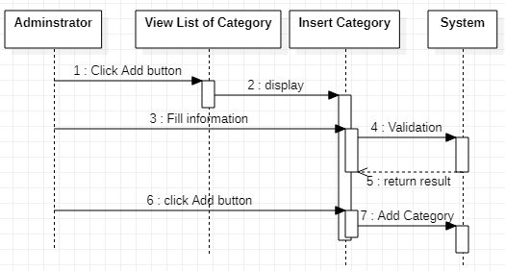

**1.6.3 Update Category**

|  |  |
| --- | --- |
| **Author** | Dinh Ngoc Minh Hieu |
| **Use Case Name** | Add Category |
| **Actors** | Administrator |
| **Description** | Administrator wants to Add new Category |
| **Requirements** |  |
| **Pre-conditions** | Actor has logged in as Administrator |
| **Post-conditions** | Success: Add Category successful Fail: Refill information |
| **Basic flow** | Actor Actions: 1. Actor clicks ‘Update’button on View list of Category page  3.Actor inputs property type information:  -Provide the Category’ Name in “Name’ text field.  -Provide the Category’ Description in “Name’ text field.  -Provide the Category’ Created_at in Created_at text field.  -Provide the Category’ Update_at in Update_at text field  5. Actor click ‘Add’ button | System Responses: 2. System redirects to View List Category page and displays form for Actor to input information with the following control :  -“Name” text feild -‘Created_at text feild -‘Update_at’ text feild -‘Description’ text feild - Add button -Cancel button  4. System checks information input  6. System add bank into database then display message ‘Your Category has been Update successful |
| **Alternative flow** | Actor click ‘Cancel’ button | System redirects to View List Category page. |
| **Exception** | Actor Actions:  -Actor left ‘Name’text field blank  -Actor left ‘Description’text field blank  -Actor left ‘Created_at’ text field blank  -Actor left ‘Update_at’ text field blank | System Responses:  -Name can’t be blank and correct format  -Description can’t be blank and correct format  -Created_at can’t be blank and correct format  -Update_at can’t be blank and correct format |

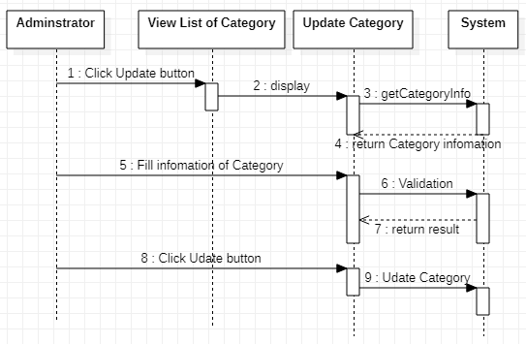

**1.6.4 Delete Category**

|  |  |
| --- | --- |
| **Author** | Dinh Ngoc Minh Hieu |
| **Use Case Name** | Delete Category |
| **Actors** | Administrator |
| **Description** | Administrator wants to Delete Category |
| **Requirements** | Administrator must be choose Category to delete |
| **Pre-conditions** | Actor has logged in as Administrator |
| **Post-conditions** | Success: Delete Category successful |
| **Basic flow** | Actor Actions: 1. Actor clicks ‘Delete’ button on View list of Category page  3. Actor clicks Yes button on popup message | System Responses: 2. System show popup message :”Do you want to remove this bank : ” + Category’s name. With Yes and No button  4. System delete bank from database then display message ‘Your Category has been delete successful’ |
| **Alternative flow** | Actor Actions: 1.Actor clicks No button | System Responses: 2.System returns to current page |
| **Exception** |  |  |

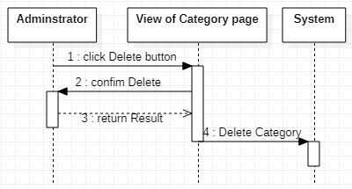

**1.7 Manage Reply**

**1.7.1 View Reply**

|  |  |
| --- | --- |
| **Author** | Dinh Ngoc Minh Hieu |
| **Use Case Name** | View List Reply |
| **Actors** | Administrator |
| **Description** | Administrator wants to View list Reply page. |
| **Requirements** |  |
| **Pre-conditions** | Actor has logged in as Administrator |
| **Post-conditions** | Success: List of Reply show successful |
| **Basic flow** | Actor Actions: 1. Actor clicks ‘Manage Reply “button on Admin page | System Responses: 2. System redirects to View List Reply page and displays form for Actor : -‘ReplyID’ label -‘FAQsID’ label -“Answer” label -‘Created_at label -‘Update_at’ label -‘Insert’ button -‘Update’ button -‘Delete’ button |
| **Alternative flow** | Actor Actions: -Actor clicks ‘Insert’ button on View List Reply page -Actor clicks ‘Update’ button on View List Reply page  -Actor clicks “Delete” button on View List Reply page | System Responses:  -System redirects to Insert Reply page  -System redirects to Update Reply page  -System redirects to Delete Reply page |
| **Exception** |  |  |

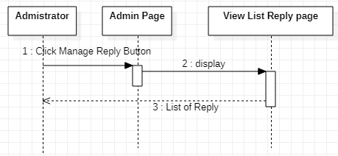

**1.7.2 Insert Reply**

|  |  |
| --- | --- |
| **Author** | Dinh Ngoc Minh Hieu |
| **Use Case Name** | Add Reply |
| **Actors** | Administrator |
| **Description** | Administrator wants to Add new Reply |
| **Requirements** |  |
| **Pre-conditions** | Actor has logged in as Administrator |
| **Post-conditions** | Success: Add Reply successful Fail: Refill information |
| **Basic flow** | Actor Actions: 1. Actor clicks ‘Add’ button on View list of Reply page  3.Actor inputs property type information:  -Provide the Reply’ Answer in “Answer’ text field.  -Provide the Reply’ Created_at in Created_at text field.  -Provide the Reply’ Update_at in Update_at text field  5. Actor click ‘Add’ button | System Responses: 2. System redirects to View List Reply page and displays form for Actor to input information with the following control :  -“Answer” label -‘Created_at label -‘Update_at’ label - Add button -Cancel button  4. System checks information input  6. System add bank into database then display message ‘Your Reply has been add successful |
| **Alternative flow** | Actor click ‘Cancel’ button | System redirects to View List Reply page. |
| **Exception** | Actor Actions:  -Actor left ‘Answer’text field blank  -Actor left ‘Created_at’ text field blank  -Actor left ‘Update_at’ text field blank | System Responses:  -Answer can’t be blank and correct format  -Created_at can’t be blank and correct format  -Update_at can’t be blank and correct format |

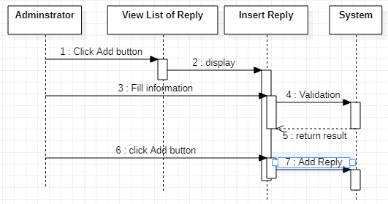

**1.7.3 Update Reply**

|  |  |
| --- | --- |
| **Author** | Dinh Ngoc Minh Hieu |
| **Use Case Name** | Update Reply |
| **Actors** | Administrator |
| **Description** | Administrator wants to Update Reply |
| **Requirements** |  |
| **Pre-conditions** | Actor has logged in as Administrator |
| **Post-conditions** | Success: Update Reply successful Fail: Refill information |
| **Basic flow** | Actor Actions: 1. Actor clicks ‘Update’ button on View list of Category page  3.Actor inputs property type information:  -Provide the Reply’ Answer in “Answer’ text field.  -Provide the Reply’ Created_at in Created_at text field.  -Provide the Reply’ Update_at in Update_at text field  5. Actor click ‘Add’ button | System Responses: 2. System redirects to View List Category page and displays form for Actor to input information with the following control :  -“Answer” text feild -‘Created_at text feild -‘Update_at’ text feild - Add button -Cancel button  4. System checks information input  6. System add bank into database then display message ‘Your Reply has been Update successful |
| **Alternative flow** | Actor click ‘Cancel’ button | System redirects to View List Reply page. |
| **Exception** | Actor Actions:  -Actor left ‘Answer’text field blank  -Actor left ‘Created_at’ text field blank  -Actor left ‘Update_at’ text field blank | System Responses:  -Answer can’t be blank and correct format  -Created_at can’t be blank and correct format  -Update_at can’t be blank and correct format |

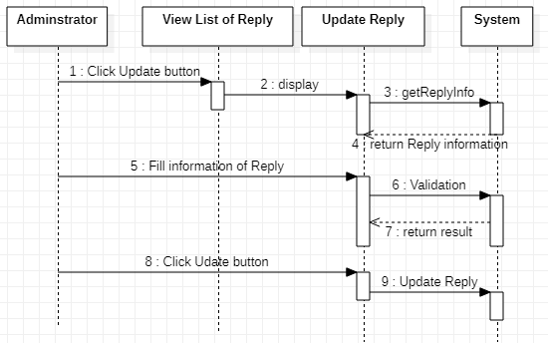

**1.7.4 Delete Reply**

|  |  |
| --- | --- |
| **Author** | Dinh Ngoc Minh Hieu |
| **Use Case Name** | Delete Reply |
| **Actors** | Administrator |
| **Description** | Administrator wants to Delete Reply |
| **Requirements** | Administrator must be choose Reply to delete |
| **Pre-conditions** | Actor has logged in as Administrator |
| **Post-conditions** | Success: Delete Reply successful |
| **Basic flow** | Actor Actions: 1. Actor clicks ‘Delete’ button on View list of Reply page  3. Actor clicks Yes button on popup message | System Responses: 2. System show popup message :”Do you want to remove this bank : ” + Reply’s name. With Yes and No button  4. System delete bank from database then display message ‘Your Reply has been delete successful’ |
| **Alternative flow** | Actor Actions: 1.Actor clicks No button | System Responses: 2.System returns to current page |
| **Exception** |  |  |

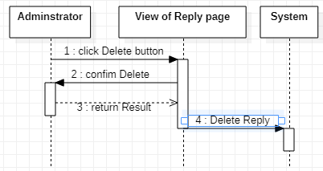

**1.8 Manage Customer**

**1.8.1 View Customer**

|  |  |
| --- | --- |
| **Author** | Dinh Ngoc Minh Hieu |
| **Use Case Name** | View List Customer |
| **Actors** | Administrator |
| **Description** | Administrator wants to View list Customer page. |
| **Requirements** |  |
| **Pre-conditions** | Actor has logged in as Administrator |
| **Post-conditions** | Success: List of Customer show successful |
| **Basic flow** | Actor Actions: 1. Actor clicks ‘Manage Customer “button on Admin page | System Responses: 2. System redirects to View List Customer page and displays form for Actor : -‘CustomerID’ label -‘Username’ label -‘Password’ label -‘Gender’ label -‘Phone’ label -‘Address’ label -‘Email’ label -‘Created_at label -‘Update_at’ label  -‘Update’ button |
| **Alternative flow** | Actor Actions: -Actor clicks ‘Update’ button on View List Reply page | System Responses:  -System redirects to Update Customer page |
| **Exception** |  |  |

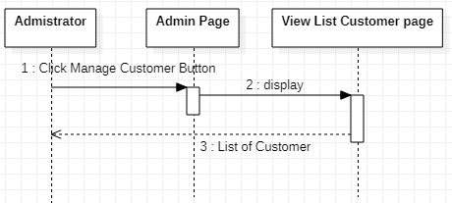

**1.8.2 Update Customer**

|  |  |
| --- | --- |
| **Author** | Dinh Ngoc Minh Hieu |
| **Use Case Name** | Update Customer |
| **Actors** | Administrator |
| **Description** | Administrator wants to Update Customer |
| **Requirements** |  |
| **Pre-conditions** | Actor has logged in as Administrator |
| **Post-conditions** | Success: Update Customer successful Fail: Refill information |
| **Basic flow** | Actor Actions: 1. Actor clicks ‘Update’ button on View list of Category page  3.Actor inputs property type information:  5. Actor click ‘Add’ button | System Responses: 2. System redirects to View List Customer page and displays form for Actor to Choose information with the following control :  -‘Status’ List box (Disable or Enable) -‘Update’ button -Cancel button  4. System checks information input  6. System add bank into database then display message ‘Your Reply has been Update successful |
| **Alternative flow** | Actor click ‘Cancel’ button | System redirects to View List Reply page. |

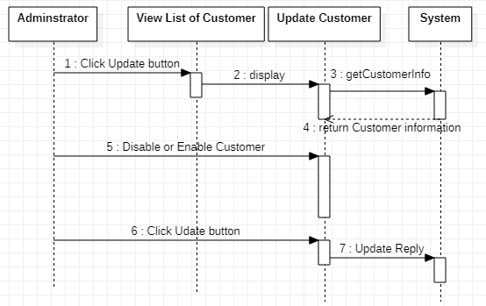

**1.9 Manage Feedback**

**1.9.1 View Feedback**

|  |  |
| --- | --- |
| **Author** | Dinh Ngoc Minh Hieu |
| **Use Case Name** | View Feedback |
| **Actors** | Administrator |
| **Description** | Administrator wants to View list Feedback page. |
| **Requirements** |  |
| **Pre-conditions** | Actor has logged in as Administrator |
| **Post-conditions** | Success: List of Feedback show successful |
| **Basic flow** | Actor Actions: 1. Actor clicks ‘Manage Feedback “button on Admin page | System Responses: 2. System redirects to View List Feedback page and displays form for Actor : -‘FeedbackID’ label -‘ContentFeedback’ label -‘Created_at label -‘Update_at’ label  -‘Update’ button -‘Delete’ button |
| **Alternative flow** | Actor Actions: -Actor clicks ‘Update’ button on View List Feedback page  -Actor clicks ‘Delete’ button on View List Feedback page | System Responses:  -System redirects to Update Feedback page  -System redirects to Delete Feedback page |
| **Exception** |  |  |

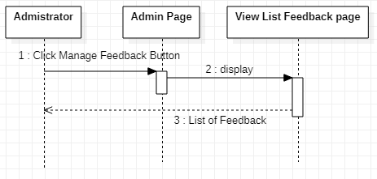

**1.9.2 Update Feedback**

|  |  |
| --- | --- |
| **Author** | Dinh Ngoc Minh Hieu |
| **Use Case Name** | Update Feedback |
| **Actors** | Administrator |
| **Description** | Administrator wants to Update Feedback |
| **Requirements** |  |
| **Pre-conditions** | Actor has logged in as Administrator |
| **Post-conditions** | Success: Update Feedback successful Fail: Refill information |
| **Basic flow** | Actor Actions: 1. Actor clicks ‘Update’ button on View list of Category page  3.Actor inputs property type information:  5. Actor click ‘Update’ button | System Responses: 2. System redirects to View List Feedback page and displays form for Actor to Choose information with the following control :  -‘ContentFeedback’ text feild -‘AnswerFeedback’ text feild -‘Update’ button  4. System checks information input  6. System add bank into database then display message ‘Your Feedback has been Update successful |
| **Alternative flow** | Actor click ‘Cancel’ button | System redirects to View List Feedback page. |
| **Exception** |  |  |

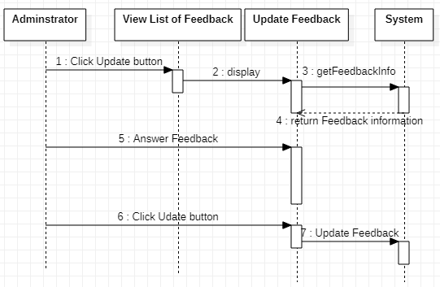

**1.9.3 Delete Feedback**

|  |  |
| --- | --- |
| **Author** | Dinh Ngoc Minh Hieu |
| **Use Case Name** | Delete Feedback |
| **Actors** | Administrator |
| **Description** | Administrator wants to Delete Feedback |
| **Requirements** | Administrator must be choose Feedback to delete |
| **Pre-conditions** | Actor has logged in as Administrator |
| **Post-conditions** | Success: Delete Feedback successful |
| **Basic flow** | Actor Actions: 1. Actor clicks ‘Delete’ button on View list of Reply page  3. Actor clicks Yes button on popup message | System Responses: 2. System show popup message :”Do you want to remove this bank : ” + FeedbackID With Yes and No button  4. System delete bank from database then display message ‘Your Feedback has been delete successful’ |
| **Alternative flow** | Actor Actions: 1.Actor clicks No button | System Responses: 2.System returns to current page |
| **Exception** |  |  |

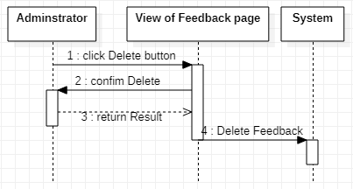

**1.10 Manage Payment**

**1.10.1 View Payment**

|  |  |
| --- | --- |
| **Author** | Dinh Ngoc Minh Hieu |
| **Use Case Name** | View Payment |
| **Actors** | Administrator |
| **Description** | Administrator wants to View list Payment page. |
| **Requirements** |  |
| **Pre-conditions** | Actor has logged in as Administrator |
| **Post-conditions** | Success: List of Feedback show successful |
| **Basic flow** | Actor Actions: 1. Actor clicks ‘Manage Payment “button on Admin page | System Responses: 2. System redirects to View List Payment page and displays form for Actor : -‘PaymentID’ label -‘CustomerId’ label -‘InsuranceId’ label -‘Content’ label -‘Amount’ label -‘Created_at label -‘Update_at’ label |

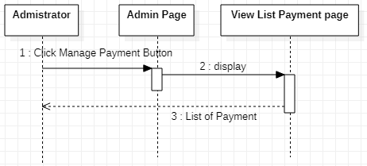

1. **Customer Use Case**

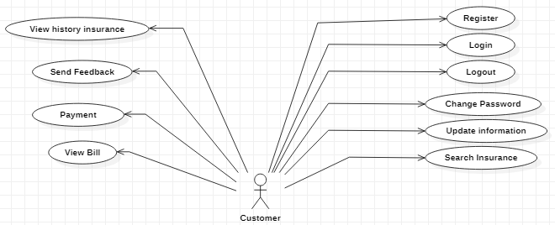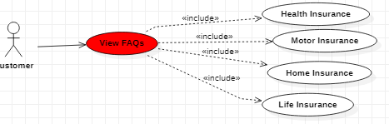

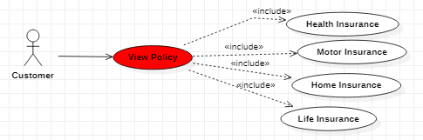

**2.1 Register**

|  |  |
| --- | --- |
| **Author** | Dinh Ngoc Minh Hieu |
| **Use Case Name** | Register |
| **Actors** | Customer |
| **Description** | Customer wants to Register |
| **Requirements** | Customer provides Customer’s Information |
| **Pre-conditions** |  |
| **Post-conditions** | Success: Register successful  Fail: Refill information |
| **Basic flow** | Actor Actions: 1. Actor clicks ‘Register’ link in Home page  3.Actor inputs register’s information and click ‘Register’ button. | System Responses: 2. System redirects to Register  page and displays Registration form with the following control : - ‘UserName’ text field - ‘Password’ text field - ‘Confirm Password’ text field - ‘Name’ text field - ‘Birthday’ datebox - ‘Gender’ checkbox group - ‘Address’ text field - ‘Phone’ text field - ‘Email’ text field - ‘Register’ button - ‘Back to Home’ button  4. System inserts the account into database, show message: ‘Your account has been created!’ and then redirects to Login page. |
| **Alternative flow** | Actor Actions: 1. Actor click ‘Back to Home’ button | System Responses: 2. System returns to Home page |
| **Exception** | Actor Actions: Actor lefts text field blank. | System Responses:  Text field can not be blank and correct format |

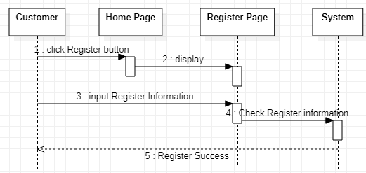

**2.2 Login**

|  |  |
| --- | --- |
| **Author** | Dinh Ngoc Minh Hieu |
| **Use Case Name** | Login |
| **Actors** | Customer |
| **Description** | Customer wants to login to page. |
| **Requirements** | Actor provides username and password |
| **Pre-conditions** |  |
| **Post-conditions** | Success:Customer logged in to website. Fail: Refill information |
| **Basic flow** | Actor Actions:  1. Actor type username and password, then click “Login” button. | System Responses: 2. System redirects to Login page and displays Login form with the following control: - ‘UserName’ text field - ‘Password’ text field - ‘Login’ button 3. System checks the information  4. System redirects to Customer Home page. |
| **Alternative flow** | Actor Actions: 1. Actor click ‘OK’ button, inputs UserName and Password, then click the Login button.  1. Actor click ‘Back to Home’ button | System Responses: 2. System checks the information 3. System redirects to Actor’s Home page  2. System returns to Home page |
| **Exception** | Actor Actions: 1. Actor lefts ‘UserName’ text field blank.  2.Actor lefts ‘Password’ text field blank. | System Responses:  System show message: - “Wrong email or password |

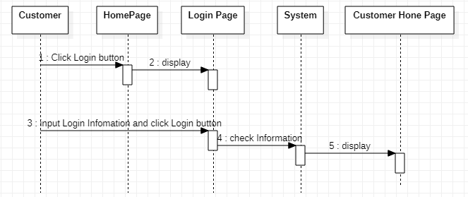

**2.3 Log out**

|  |  |
| --- | --- |
| **Author** | Dinh Ngoc Minh Hieu |
| **Use Case Name** | Logout |
| **Actors** | Customer |
| **Description** | Customer want to logout |
| **Requirements** |  |
| **Pre-conditions** |  |
| **Post-conditions** |  |
| **Basic flow** | Actor action: 1. Visitor click “Logout” button on the Actor’s Home Menu | System Responses: 2. System redirect to Logout page delete customer session data and then redirect to Login page |
| **Alternative flow** |  |  |
| **Exception** |  |  |

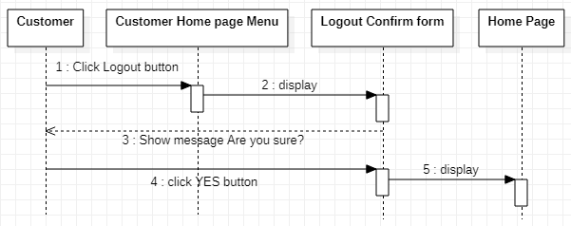

**2.4 Update Infomation**

|  |  |
| --- | --- |
| **Author** | Dinh Ngoc Minh Hieu |
| **Use Case Name** | Update Profile |
| **Actors** | Customer |
| **Description** | Customer wants to Update Profile |
| **Requirements** | Customer provides profile Information |
| **Pre-conditions** | Customer has logged in |
| **Post-conditions** | Success: Updatesuccessful  Fail: Refill information |
| **Basic flow** | Actor Actions: 1. Actor clicks ‘Update Profile’ button in Actor’s Home page.  3. Actor updates information and click ‘Save’ button | System Responses: 2. System redirects to Register  page and displays Registration form with the following control : - ‘UserName’ text field - ‘Old Password’ text field - ‘New Password’ text field - ‘New Password Confirm’ text field - ‘Name’ text field - ‘Birthday’ datebox - ‘Gender’ checkbox group - ‘Address’ text field - ‘Phone’ text field - ‘Email’ text field - ‘Save’ button - ‘Back to Home’ button  4. System checks the information 5. System update the account into database and then redirects to Actor Home page |
| **Alternative flow** | Actor Actions: 1. Actor click ‘Back to Home’ button | System Responses: 2. System returns to Home page |
| **Exception** | Actor Actions: Actor lefts text field blank. | System Responses:  Text field can not be blank and correct format |

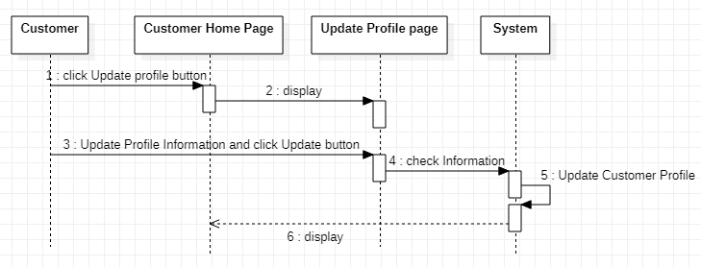

**2.5 Payment**

|  |  |
| --- | --- |
| **Author** | Dinh Ngoc Minh Hieu |
| **Use Case Name** | Payment |
| **Actors** | Customer |
| **Description** | Customer wants to Payment |
| **Requirements** | Customer provides profile Information and payment method |
| **Pre-conditions** | Customer has logged in |
| **Post-conditions** | Success: Payment successful  Fail: Refill information |
| **Basic flow** | Actor Actions: 1. Actor Select the type of insurance want to buy and click pay clicks ‘Want to Buy’ button  3. Actor fill in the information and proceed to the payment through the account and click ‘Buy’ button | System Responses: 2. System redirects to Payment page and displays Payment form. Fill in the information and proceed to the payment through the account.  4. System checks the information  5. System updates user’s purchase status show Buy Package Success form |
| **Alternative flow** | Actor Actions: 1. Actor click ‘Back to Home’ button | System Responses: 2. System returns to Home page |
| **Exception** | Actor Actions: Actor lefts text field blank. | System Responses:  Text field can not be blank and correct format |

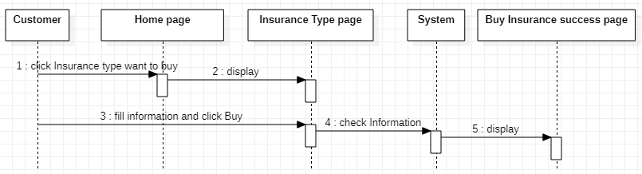

**2.6 View Policy (For User)**

|  |  |
| --- | --- |
| **Author** | Dinh Ngoc Minh Hieu |
| **Use Case Name** | View Policy |
| **Actors** | Customer |
| **Description** | Customer wants View Policy |
| **Requirements** |  |
| **Pre-conditions** |  |
| **Post-conditions** | Success: View Poicy  Fail: Refill information |
| **Basic flow** | Actor Actions: 1. Actor clicks Policy link in Home page | System Responses: 2. The web page displays the linked page. |

**2.7 View FAQs**

|  |  |
| --- | --- |
| **Author** | Dinh Ngoc Minh Hieu |
| **Use Case Name** | View FAQs |
| **Actors** | Customer |
| **Description** | Customer wants View FAQs |
| **Requirements** |  |
| **Pre-conditions** |  |
| **Post-conditions** | Success: View FAQs  Fail: Refill information |
| **Basic flow** | Actor Actions: 1. Actor clicks FAQs link in Home page | System Responses: 2. The web page displays the linked page. |

# 

## 

# Algorithms – Data Flowchart

## 1.Symbol generates:



## 2.Main data flowchart (for Customer)

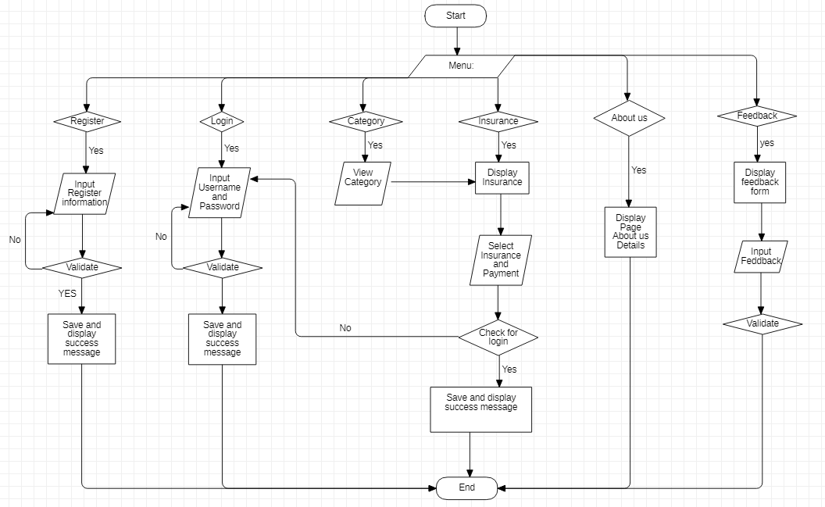

## 3. Login process (For admin)

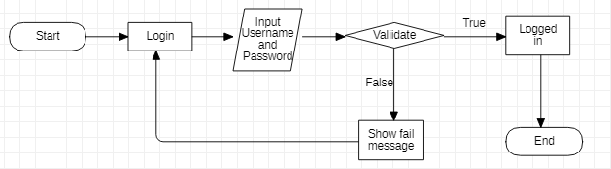

## 4. Logout process (For admin)

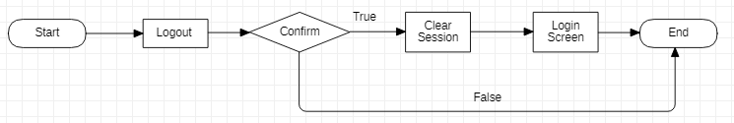

## 5.Update Customer’s information (For Customer)

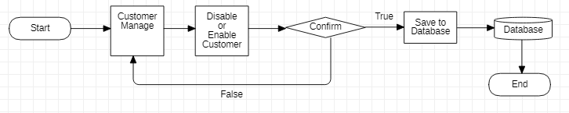

## 6.Insert category (for Admin)

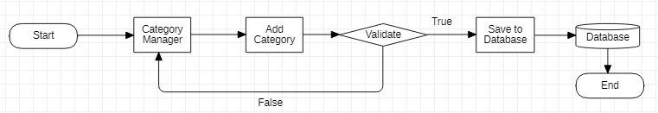

## 7.Update category (for Admin only)

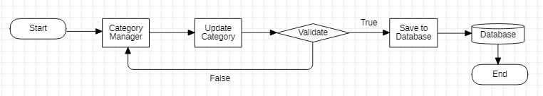

## 8.Delete category (For Admin)

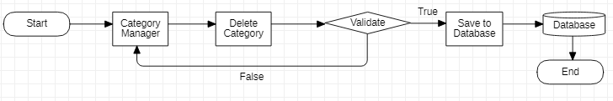

## 9.Insert Policy (For Admin)

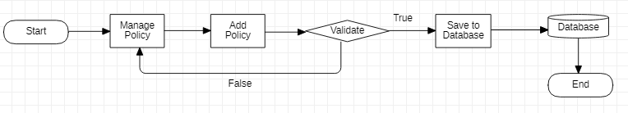

## 10.Update Policy (For Admin)

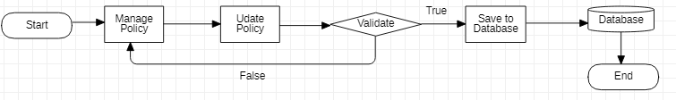

## 11.Delete Policy (For Admin)

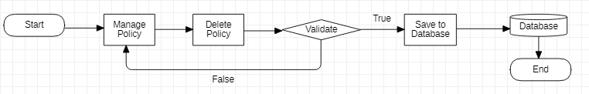

## 12.Insert FAQs (For Admin)

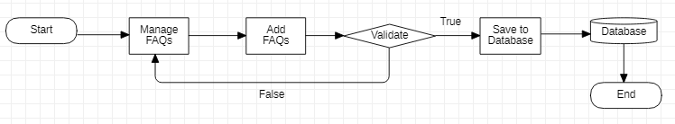

## 13.Update FAQs (For Admin)

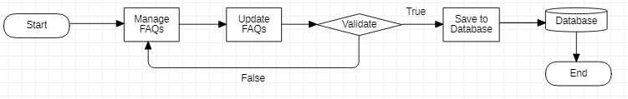

## 14.Delete FAQs (For admin)

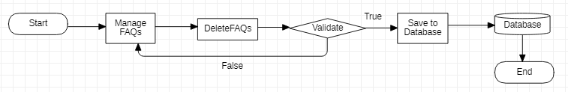

## 15.Insert Reply (For admin)

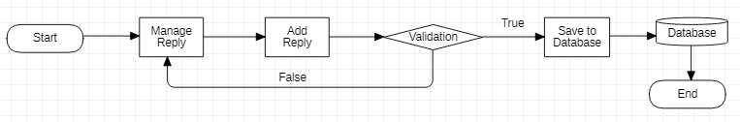

## 16.Update Reply (for Admin)

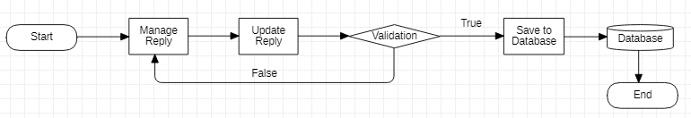

## 17.Delete Reply (for Admin)

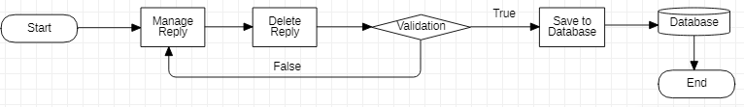

## 18.Update Feedback (For Admin)

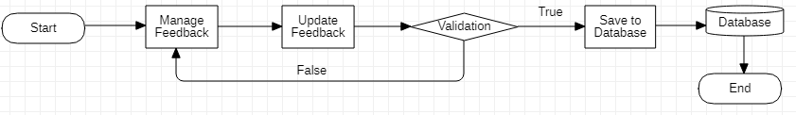

## 19.Delete Feedback (For Admin)

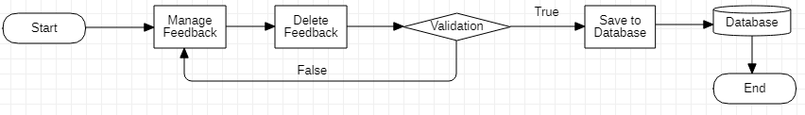

**IV.Entity – Relationship Diagrams**

1. **Entity – Relationship Diagram**

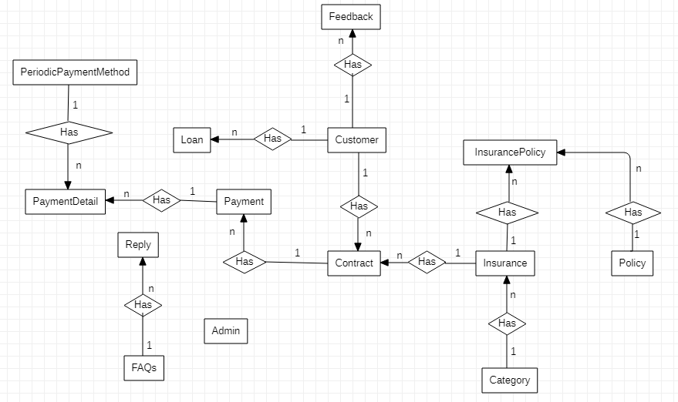

1. **Entity – Relationship Diagram Symbols**

|  |  |
| --- | --- |
| Entity | Representing an entity |
| Relationship | Representing a relationship between two entities |
|  | An attribute of entity |
|  | This attribute is primary key |

**3.****Entities and Properties  
3.1 Category**

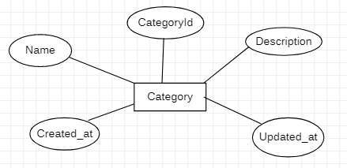

**3.2 Insurance**

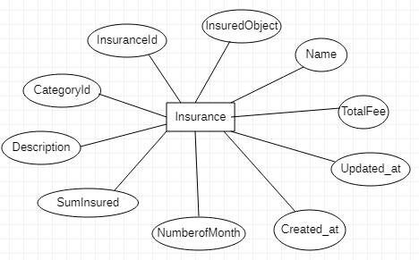

**3.3 Customer**

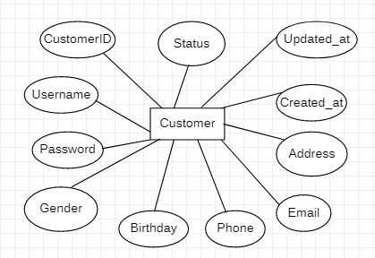

**3.4 Contract**

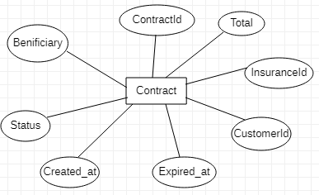

**3.5 Loan**

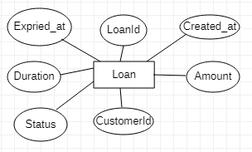

**3.6 Policy**

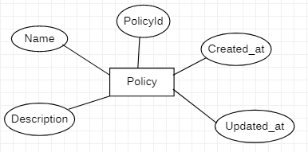

**3.7 FAQs**

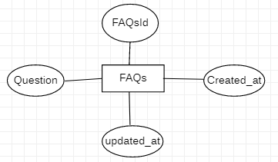

**3.8 Repy**

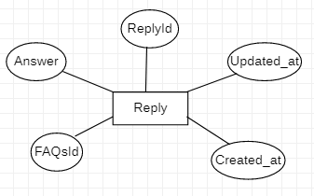

**3.9 Payment**

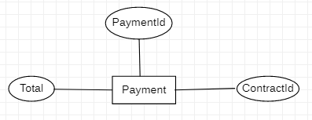

**3.10 PaymentDetail**

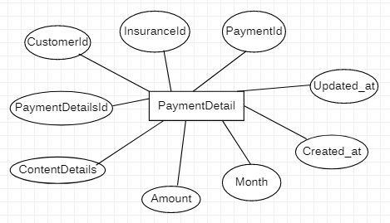

**3.11 Feedback**

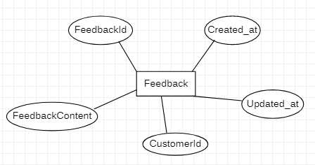

**3.12 PeriodicPaymentMethod**

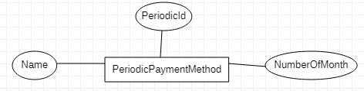

**3.13 Admin**

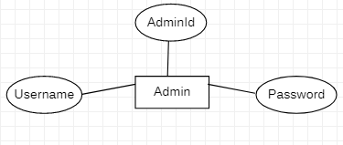

**3.14 InsurancePolicy**

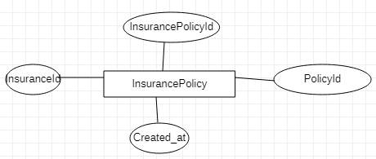

**TASK SHEET REVIEW 2**

|  |  |
| --- | --- |
| **Date:** | |
| Signature of Instructor:  **Mr. Hoang Duc Quang** | Signature of Team Leader:  **Do Thanh Nam** |

|  |  |  |  |  |  |  |  |
| --- | --- | --- | --- | --- | --- | --- | --- |
| **Project Ref. No.:**  **eP/Advertisement** **Portal Management** **System/01** | | **Project Title:** | **Activity Plan** **Prepared** **By:** | **Date of Preparation of Activity Plan:** | | | |
| **Sr.No.** | **Task** | **Actual Start** **Date** | **Actual** **Days** | **Team** **Mate** **Names** | **Status** |
| 1 | Architecture & Design of Project | Insurance Online | Nam | 08/05/2022 | 1 | All Member | Completed |
| 2 | Class Diagram | 08/05/2022 | 2 | All Member | Completed |
| 3 | Algorithms – Data Flowchart | 08/05/2022 | 1 | All Member | Completed |
| 4 | Entity-Relationship Diagram | 08/05/2022 | 3 | Hieu | Completed |
| 5 | Task sheet review | 08/05/2022 | 1 | Hieu | Completed |

# REVIEW 3

# DATABASE DESIGN

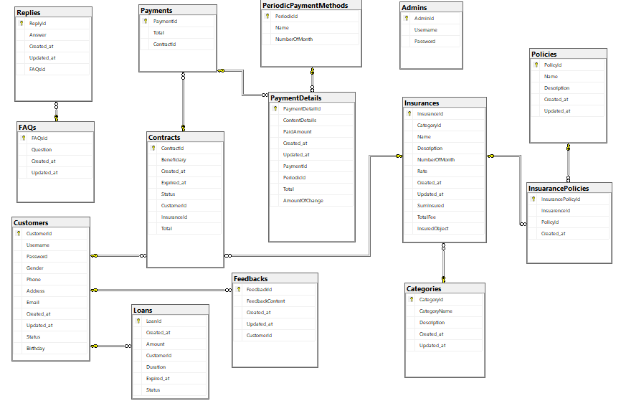

# DATABASE STRUCTURE

**1.Table Admins**CREATE TABLE [dbo].[Admins](

[AdminId] [int] IDENTITY (1,1) NOT NULL,

[Username] [varchar] (255) NULL,

[Password] [varchar] (255) NULL,

CONSTRAINT [PK_Admins] PRIMARY KEY CLUSTERED

(

[AdminId] ASC

) WITH (PAD_INDEX = OFF, STATISTICS_NORECOMPUTE = OFF, IGNORE_DUP_KEY = OFF, ALLOW_ROW_LOCKS = ON, ALLOW_PAGE_LOCKS = ON) ON [PRIMARY]

) ON [PRIMARY]

**2.Table Categories**CREATE TABLE [dbo].[Categories](

[CategoryId] [int] IDENTITY (1,1) NOT NULL,

[CategoryName] [nvarchar] (255) NULL,

[Description] [nvarchar] (255) NULL,

[Created_at] [datetime] NULL,

[Updated_at] [datetime] NULL,

CONSTRAINT [PK_Categories] PRIMARY KEY CLUSTERED

(

[CategoryId] ASC

) WITH (PAD_INDEX = OFF, STATISTICS_NORECOMPUTE = OFF, IGNORE_DUP_KEY = OFF, ALLOW_ROW_LOCKS = ON, ALLOW_PAGE_LOCKS = ON) ON [PRIMARY]

) ON [PRIMARY]  
  
**3.Table Contracts**CREATE TABLE [dbo].[Contracts](

[ContractId] [int] IDENTITY (1,1) NOT NULL,

[Benificiary] [nvarchar] (255) NULL,

[Created_at] [datetime] NULL,

[Exprired] [datetime] NULL,

[Status] [bit] NULL,

[CustomerId] [int] NULL,

[InsuranceId] [int] NULL,

[Total] [money] NULL,

CONSTRAINT [PK_Contracts] PRIMARY KEY CLUSTERED

(

[ContractId] ASC

) WITH (PAD_INDEX = OFF, STATISTICS_NORECOMPUTE = OFF, IGNORE_DUP_KEY = OFF, ALLOW_ROW_LOCKS = ON, ALLOW_PAGE_LOCKS = ON) ON [PRIMARY]

) ON [PRIMARY] **4.Table Customers**CREATE TABLE [dbo].[Customers](

[CustomerId] [int] IDENTITY (1,1) NOT NULL,

[Username] [nvarchar] (255) NULL,

[Password] [nvarchar] (255) NULL,

[Gender] [bit] NULL,

[Phone] [varchar] (12) NULL,

[Address] [nvarchar] (255) NULL,

[Email] [nvarchar] (255) NULL,

[Created_at] [datetime] NULL,

[Updated_at] [datetime] NULL,

[Status] [bit] NULL,

[Birthday] [datetime] NULL,

CONSTRAINT [PK_Customers] PRIMARY KEY CLUSTERED

(

[CustomerId] ASC

) WITH (PAD_INDEX = OFF, STATISTICS_NORECOMPUTE = OFF, IGNORE_DUP_KEY = OFF, ALLOW_ROW_LOCKS = ON, ALLOW_PAGE_LOCKS = ON) ON [PRIMARY]) ON [PRIMARY]

**5.Table FAQs**CREATE TABLE [dbo].[FAQs](

[FAQsId] [int] IDENTITY (1,1) NOT NULL,

[Question] [nvarchar] (255) NULL,

[Created_at] [datetime] NULL,

[Updated_at] [datetime] NULL,

CONSTRAINT [PK_FAQs] PRIMARY KEY CLUSTERED

(

[FAQsId] ASC

) WITH (PAD_INDEX = OFF, STATISTICS_NORECOMPUTE = OFF, IGNORE_DUP_KEY = OFF, ALLOW_ROW_LOCKS = ON, ALLOW_PAGE_LOCKS = ON) ON [PRIMARY]

) ON [PRIMARY]  
  
**6.Table Feedbacks**CREATE TABLE [dbo].[Feedbacks](

[FeedbackId] [int] IDENTITY (1,1) NOT NULL,

[FeedbackContent] [nvarchar] (255) NULL,

[Created_at] [datetime] NULL,

[Updated_at] [datetime] NULL,

[CustomerId] [int] NULL,

CONSTRAINT [PK_Feedbacks] PRIMARY KEY CLUSTERED

(

[FeedbackId] ASC

) WITH (PAD_INDEX = OFF, STATISTICS_NORECOMPUTE = OFF, IGNORE_DUP_KEY = OFF, ALLOW_ROW_LOCKS = ON, ALLOW_PAGE_LOCKS = ON) ON [PRIMARY]

) ON [PRIMARY]

**7.Table InsurancePolicies**

CREATE TABLE [dbo].[InsuarancePolicies](

[InsurancePolicyId] [int] IDENTITY (1,1) NOT NULL,

[InsuarenceId] [int] NULL,

[PolicyId] [int] NULL,

[Created_at] [datetime] NULL,

CONSTRAINT [PK_InsuarancePolicies] PRIMARY KEY CLUSTERED

(

[InsurancePolicyId] ASC

) WITH (PAD_INDEX = OFF, STATISTICS_NORECOMPUTE = OFF, IGNORE_DUP_KEY = OFF, ALLOW_ROW_LOCKS = ON, ALLOW_PAGE_LOCKS = ON) ON [PRIMARY]

) ON [PRIMARY]  
  
**8.Table Insurances**CREATE TABLE [dbo].[Insurances](

[InsuranceId] [int] IDENTITY (1,1) NOT NULL,

[CategoryId] [int] NULL,

[Name] [nvarchar] (255) NULL,

[Description] [nvarchar] (255) NULL,

[NumberOfMonth] [int] NULL,

[Rate] [float] NULL,

[Created_at] [datetime] NULL,

[Updated_at] [datetime] NULL,

[SumInsured] [money] NULL,

[TotalFee] [money] NULL,

[InsuredObject] [nvarchar](50) NULL,

CONSTRAINT [PK_Insurances] PRIMARY KEY CLUSTERED

(

[InsuranceId] ASC

) WITH (PAD_INDEX = OFF, STATISTICS_NORECOMPUTE = OFF, IGNORE_DUP_KEY = OFF, ALLOW_ROW_LOCKS = ON, ALLOW_PAGE_LOCKS = ON) ON [PRIMARY]

) ON [PRIMARY]

**9.Table Loans**CREATE TABLE [dbo].[Loans](

[LoanId] [int] IDENTITY (1,1) NOT NULL,

[Created_at] [datetime] NULL,

[Amount] [money] NULL,

[CustomerId] [int] NULL,

[Duration] [int] NULL,

[Expired_at] [datetime] NULL,

[Status] [bit] NULL,

CONSTRAINT [PK_Loan] PRIMARY KEY CLUSTERED

(

[LoanId] ASC

) WITH (PAD_INDEX = OFF, STATISTICS_NORECOMPUTE = OFF, IGNORE_DUP_KEY = OFF, ALLOW_ROW_LOCKS = ON, ALLOW_PAGE_LOCKS = ON) ON [PRIMARY]

) ON [PRIMARY]

**10.Table PaymentDetails**CREATE TABLE [dbo].[PaymentDetails](

[PaymentDetailId] [int] IDENTITY (1,1) NOT NULL,

[ContentDetails] [varchar] (255) NULL,

[PaidAmount] [money] NULL,

[Created_at] [datetime] NULL,

[Updated_at] [datetime] NULL,

[PaymentId] [int] NULL,

[PeriodicId] [int] NULL,

[Total] [money] NULL,

[AmountOfChange] [money] NULL,

CONSTRAINT [PK_PaymentDetail] PRIMARY KEY CLUSTERED

(

[PaymentDetailId] ASC

) WITH (PAD_INDEX = OFF, STATISTICS_NORECOMPUTE = OFF, IGNORE_DUP_KEY = OFF, ALLOW_ROW_LOCKS = ON, ALLOW_PAGE_LOCKS = ON) ON [PRIMARY]

) ON [PRIMARY]  
**11.Table Payments**CREATE TABLE [dbo].[Payments](

[PaymentId] [int] IDENTITY (1,1) NOT NULL,

[Total] [money] NULL,

[ContractId] [int] NULL,

CONSTRAINT [PK_Payments] PRIMARY KEY CLUSTERED

(

[PaymentId] ASC

) WITH (PAD_INDEX = OFF, STATISTICS_NORECOMPUTE = OFF, IGNORE_DUP_KEY = OFF, ALLOW_ROW_LOCKS = ON, ALLOW_PAGE_LOCKS = ON) ON [PRIMARY]

) ON [PRIMARY]

**12.Table Policies**CREATE TABLE [dbo].[Policies](

[PolicyId] [int] IDENTITY (1,1) NOT NULL,

[Name] [nvarchar] (255) NULL,

[Description] [nvarchar] (255) NULL,

[Created_at] [datetime] NULL,

[Updated_at] [datetime] NULL,

CONSTRAINT [PK_Policys] PRIMARY KEY CLUSTERED

(

[PolicyId] ASC

) WITH (PAD_INDEX = OFF, STATISTICS_NORECOMPUTE = OFF, IGNORE_DUP_KEY = OFF, ALLOW_ROW_LOCKS = ON, ALLOW_PAGE_LOCKS = ON) ON [PRIMARY]

) ON [PRIMARY]

**13.Table PeriodicPaymentMethods**

CREATE TABLE [dbo]. [PeriodicPaymentMethods] (

[PeriodicId] [int] IDENTITY (1,1) NOT NULL,

[Name] [nvarchar] (50) NULL,

[NumberOfMonth] [int] NULL,

CONSTRAINT [PK_PeriodicPaymentMethods] PRIMARY KEY CLUSTERED

(

[PeriodicId] ASC

) WITH (PAD_INDEX = OFF, STATISTICS_NORECOMPUTE = OFF, IGNORE_DUP_KEY = OFF, ALLOW_ROW_LOCKS = ON, ALLOW_PAGE_LOCKS = ON) ON [PRIMARY]

) ON [PRIMARY]

**14.Table Replys**CREATE TABLE [dbo].[Replys](

[ReplyId] [int] IDENTITY (1,1) NOT NULL,

[Answer] [varchar] (255) NULL,

[Created_at] [datetime] NULL,

[Updated_at] [datetime] NULL,

[FAQsId] [int] NULL,

CONSTRAINT [PK_Replys] PRIMARY KEY CLUSTERED

(

[ReplyId] ASC

) WITH (PAD_INDEX = OFF, STATISTICS_NORECOMPUTE = OFF, IGNORE_DUP_KEY = OFF, ALLOW_ROW_LOCKS = ON, ALLOW_PAGE_LOCKS = ON) ON [PRIMARY]

) ON [PRIMARY]

# GUI DESIGN Front-end(Customer)

**1.HOMEPAGE**

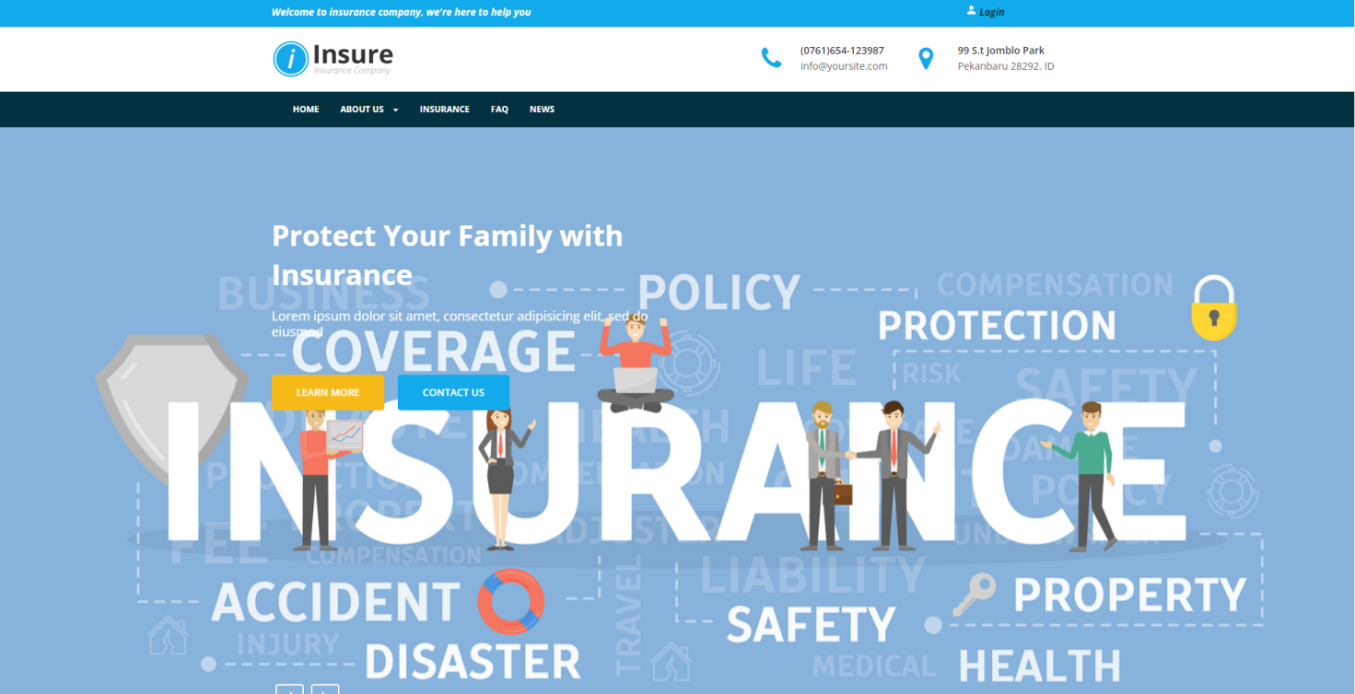

|  |  |  |  |  |  |
| --- | --- | --- | --- | --- | --- |
| **Name** | **Type** | **Validation** | **Event** | **Description** | **Status** |
|  |  |  |  |  |  |
| Navigation Bar | Hyperlink |  | Click | Choose and go to pages | Enable |
|  |  |  |  |  |  |
| Log In / Register | Button |  | Click | Click to go to Log in/ Register page | Enable |
|  |  |  |  |  |  |
| About Us | Hyperlink |  | Click | Click to go to About us Page | Enable |
|  |  |  |  |  |  |
| Insurance | Hyperlink |  | Click | Click to go to Detail | Enable |
|  |  |  |  | page/Insurance Page |  |
|  |  |  |  |  |  |
| FAQ’s | Hyperlink |  | Click | Click to go to Faq’s Page | Enable |
|  |  |  |  |  |  |
| New | Hyperlink |  | Click | Click to go to New Page | Enable |
|  |  |  |  |  |  |
|  |  |  |  |  |  |

**1.2 About Us**

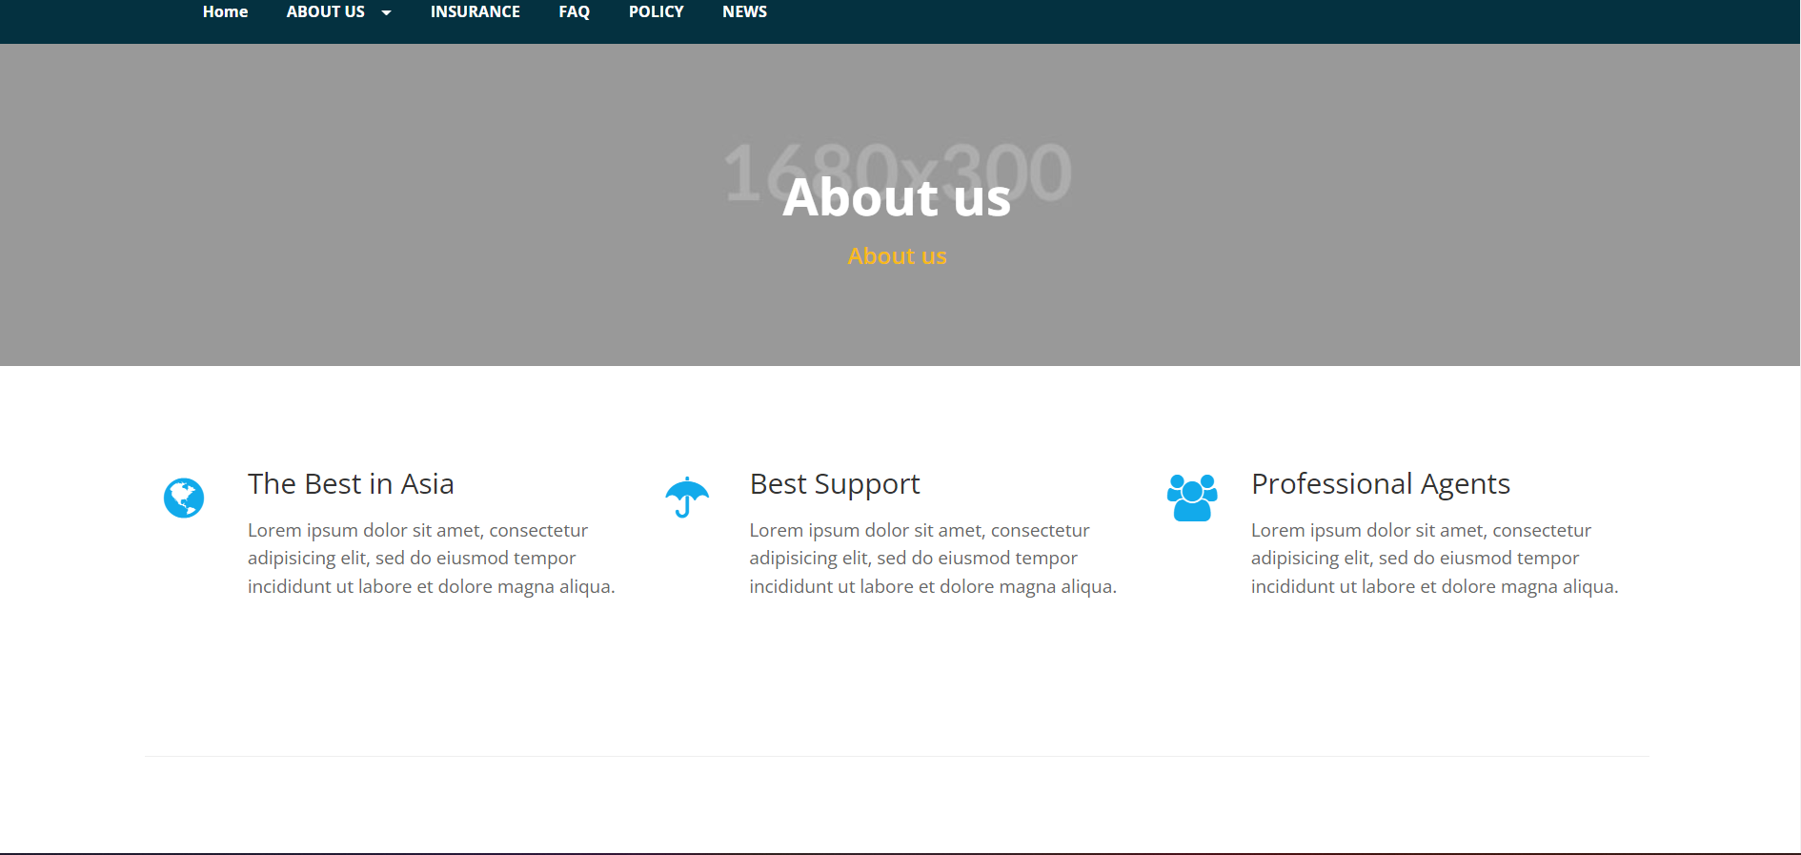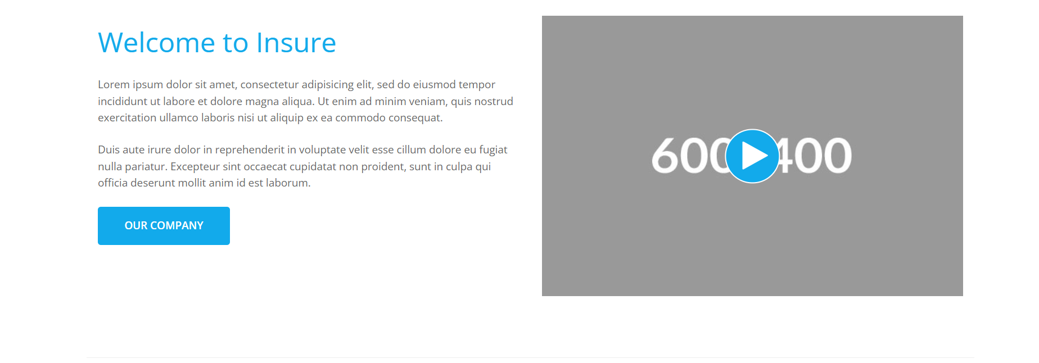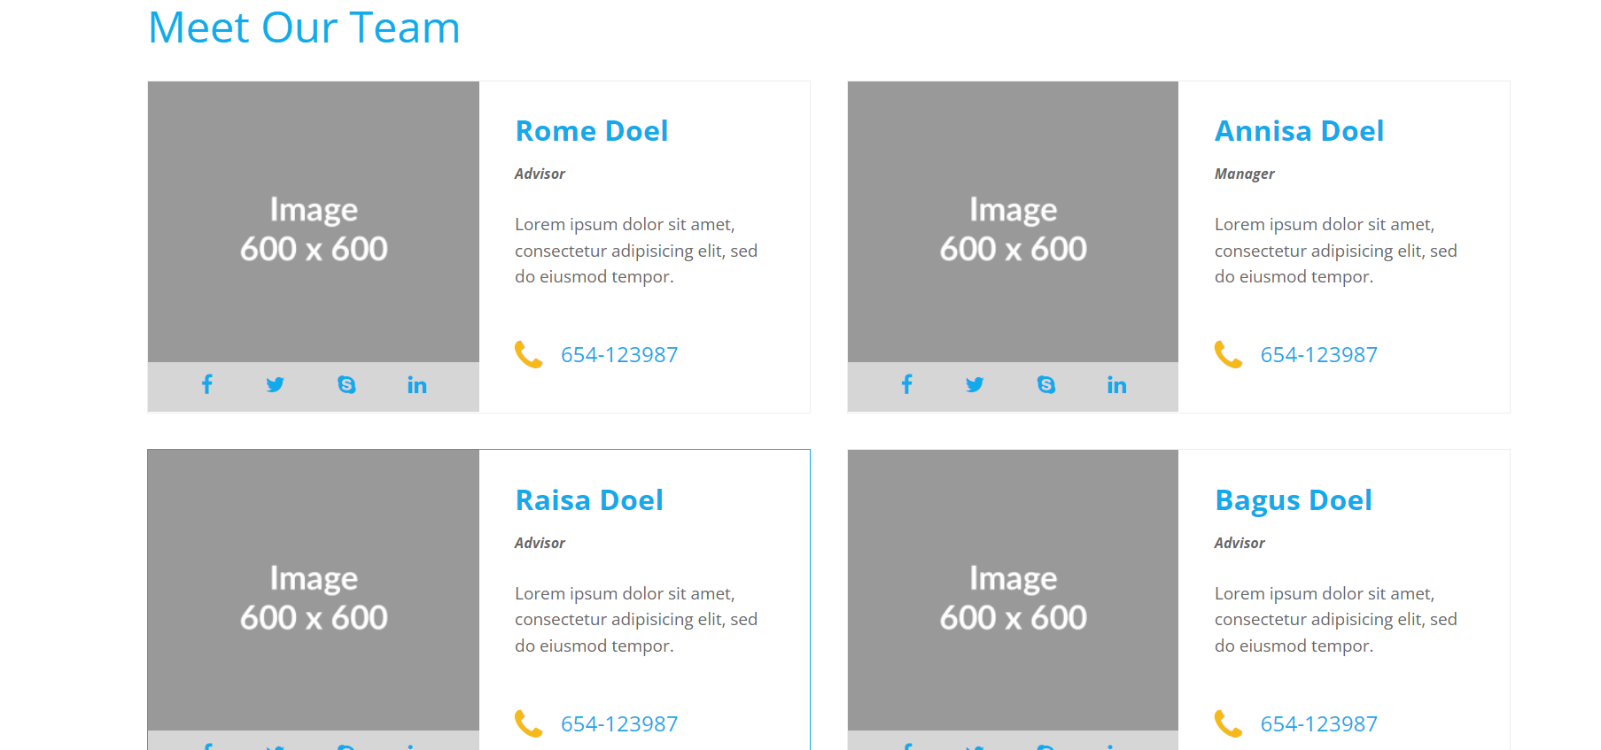

|  |  |  |  |  |  |  |  |  |  |  |  |  |
| --- | --- | --- | --- | --- | --- | --- | --- | --- | --- | --- | --- | --- |
| **No** |  |  | **Name** |  | **Type** |  | **Validation** |  | **Event** |  | **Description** | **Status** |
|  |  |  |  |  |  |  |  |  |  |  |  |  |
| 1 |  |  | Navigation Bar |  | Hyperlink |  |  |  | Click |  | Choose and go to pages | Enable |
|  |  |  |  |  |  |  |  |  |  |  |  |  |
| 2 |  |  | Insurance |  | Input |  | Required |  | Focus |  | |  | | --- | | Click to go to Detail | | page/Insurance Page | | Enable |
|  |  |  |  |  |  |  |  |  |  |  |  |  |
| 3 |  |  | FaceBook |  | Input |  | Required |  | Focus |  | Click to go to Page Facebook | Enable |
|  |  |  |  |  |  |  |  |  |  |  |  |  |

**1.3 Register**

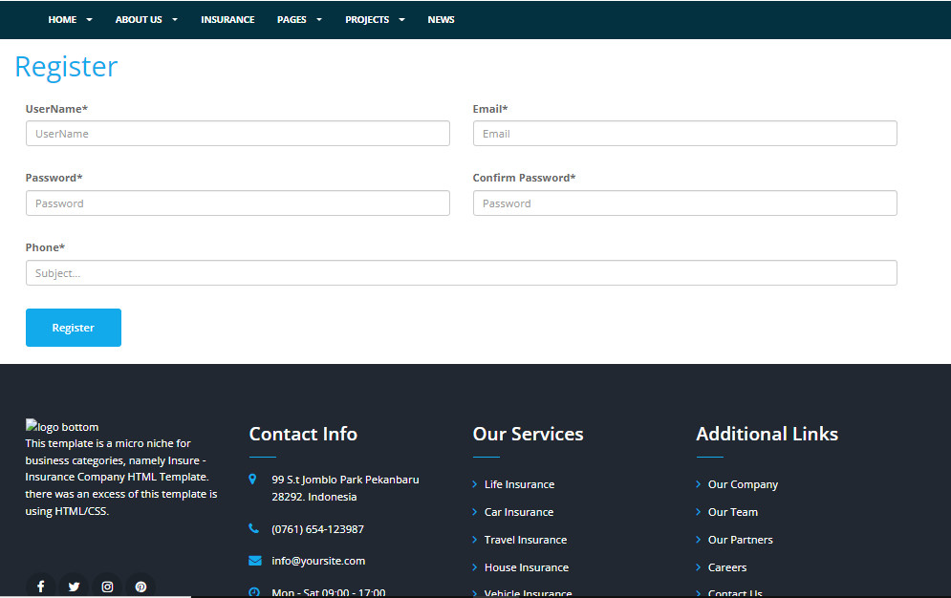

|  |  |  |  |  |  |  |  |  |  |  |  |  |
| --- | --- | --- | --- | --- | --- | --- | --- | --- | --- | --- | --- | --- |
| **No** |  |  | **Name** |  | **Type** |  | **Validation** |  | **Event** |  | **Description** | **Status** |
|  |  |  |  |  |  |  |  |  |  |  |  |  |
| 1 |  |  | Navigation Bar |  | Hyperlink |  |  |  | Click |  | Choose and go to pages | Enable |
|  |  |  |  |  |  |  |  |  |  |  |  |  |
| 2 |  |  | Username |  | Input |  | Required |  | Focus |  | Input Username | Enable |
|  |  |  |  |  |  |  |  |  |  |  |  |  |
| 3 |  |  | Password |  | Input |  | Required |  | Focus |  | Input Password | Enable |
|  |  |  |  |  |  |  |  |  |  |  |  |  |
| 4 |  |  | Email |  | Input |  | Required |  | Focus |  | Input Email | Enable |
|  |  |  |  |  |  |  |  |  |  |  |  |  |
| 5 |  |  | Member Option |  | Radio |  | Required |  | Focus |  | Input Password | Enable |
|  |  |  |  |  |  |  |
|  |  |  |  |  | Button |  |  |  |  |  |  |  |
|  |  |  |  |  |  |  |  |  |  |  |  |  |
| 6 |  |  | Click here to Log In |  | Hyperlink |  |  |  | click |  | Click back to Log In Page | Enable |
|  |  |  |  |  |  |  |  |  |  |  |  |  |

**1.4 Login**

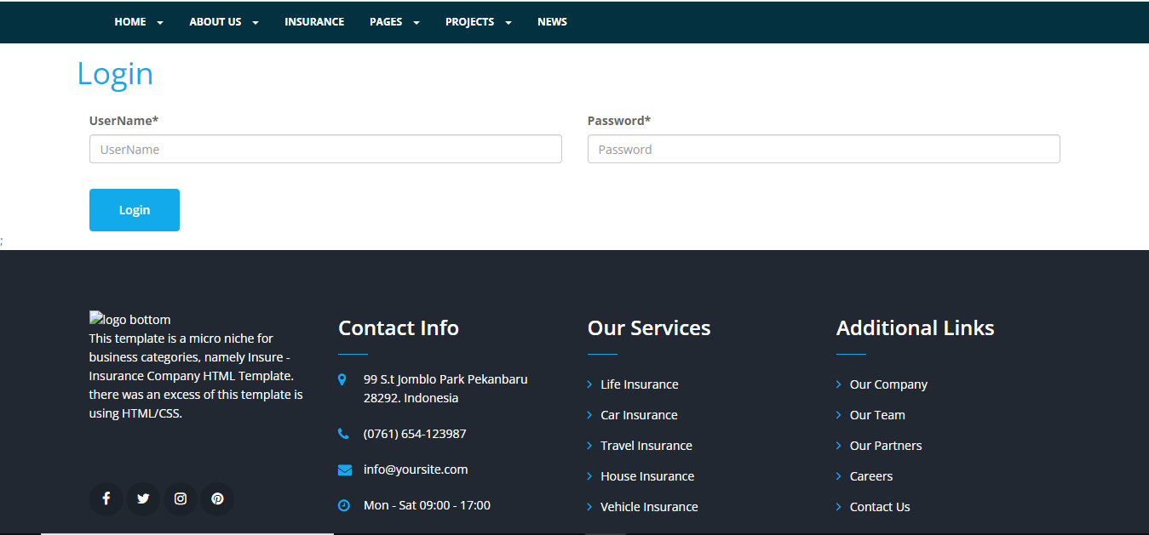

|  |  |  |  |  |  |  |
| --- | --- | --- | --- | --- | --- | --- |
| **No** | **Name** | **Type** | **Validation** | **Event** | **Description** | **Status** |
|  |  |  |  |  |  |  |
| 1 | Navigation Bar | Hyperlink |  | Click | Choose and go to pages | Enable |
|  |  |  |  |  |  |  |
| 2 | Username | Input | Required | Focus | Input Username | Enable |
|  |  |  |  |  |  |  |
| 3 | Password | Input | Required | Focus | Input Password | Enable |
|  |  |  |  |  |  |  |
| 4 | Login | Button |  | Click | Log in | Enable |
|  |  |  |  |  |  |  |

**1.5 FAQ**

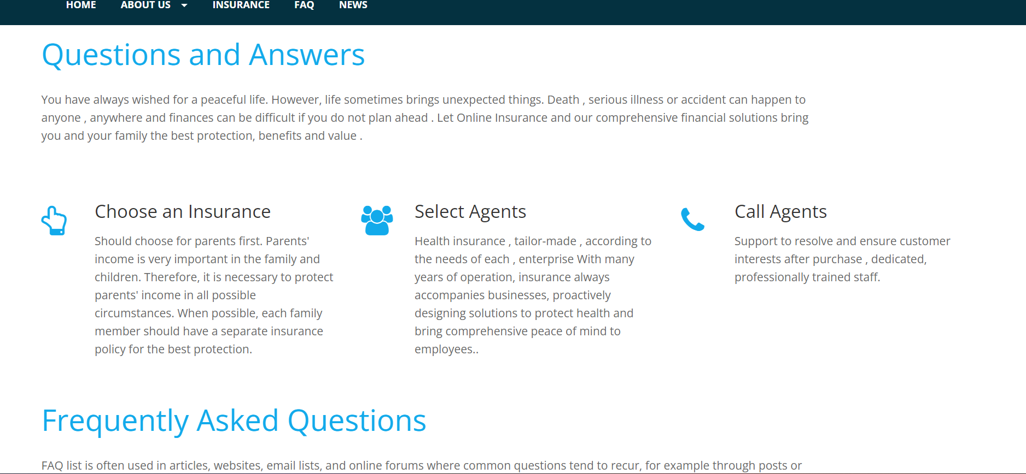

|  |  |  |  |  |  |  |
| --- | --- | --- | --- | --- | --- | --- |
| **No** | **Name** | **Type** | **Validation** | **Event** | **Description** | **Status** |
|  |  |  |  |  |  |  |
| 1 | Navigation Bar | Hyperlink |  | Click | Choose and go to pages | Enable |
|  |  |  |  |  |  |  |

**1.6 Insurance**

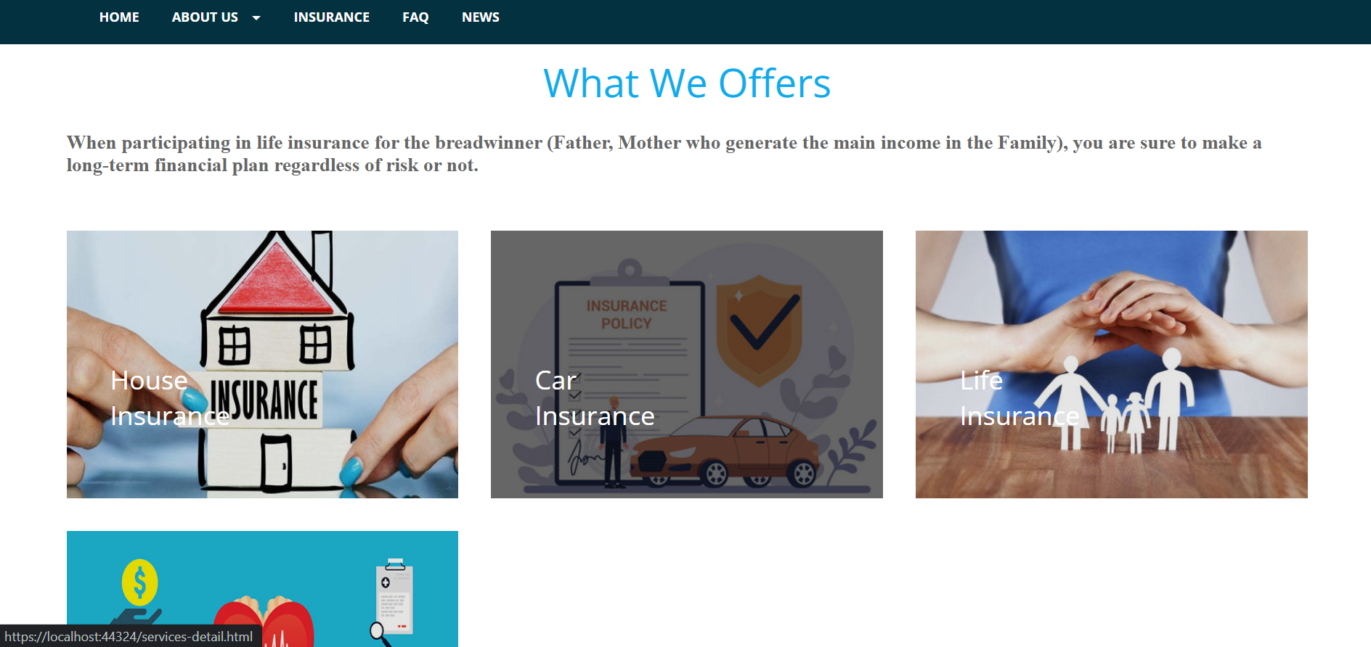

|  |  |  |  |  |  |  |  |  |  |  |  |  |
| --- | --- | --- | --- | --- | --- | --- | --- | --- | --- | --- | --- | --- |
| **No** |  |  | **Name** |  | **Type** |  | **Validation** |  | **Event** |  | **Description** | **Status** |
|  |  |  |  |  |  |  |  |  |  |  |  |  |
| 1 |  |  | Navigation Bar |  | Hyperlink |  |  |  | Click |  | Choose and go to pages | Enable |
|  |  |  |  |  |  |  |  |  |  |  |  |  |
| 2 |  |  | House Insurance |  | Hyperlink |  |  |  | Click |  | Choose and go to Detail Pages | Enable |
|  |  |  |  |  |  |  |  |  |  |  |  |  |
| 3 |  |  | Car Insurance |  | Hyperlink |  |  |  | Click |  | Choose and go to Detail Pages | Enable |
|  |  |  |  |  |  |  |  |  |  |  |  |  |
| 4 |  |  | Life Insurance |  | Hyperlink |  |  |  | Click |  | Choose and go to Detail Pages | Enable |
|  |  |  |  |  |  |  |  |  |  |  |  |  |
| 6 |  |  | Medical Insurance |  | Hyperlink |  |  |  | Click |  | Choose and go to Detail Pages | Enable |
|  |  |  |  |  |  |  |  |  |  |  |  |  |

**1.6.1 Insurance Detail**

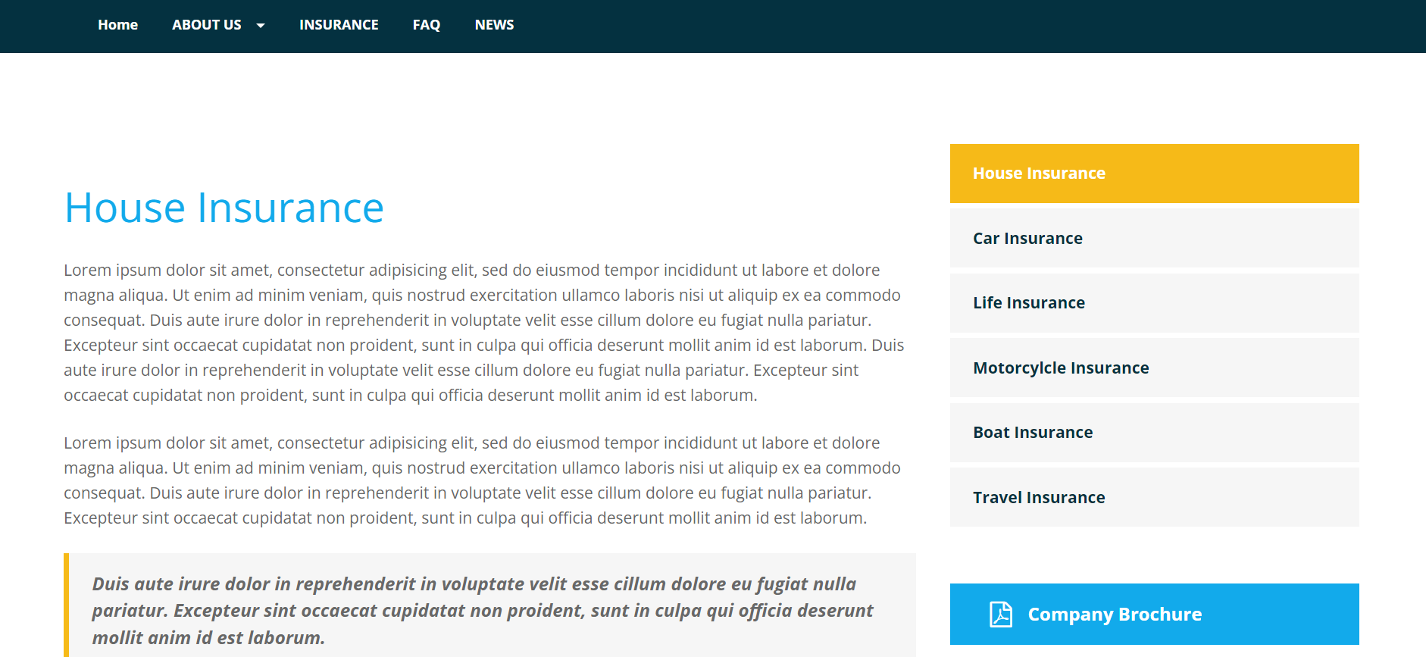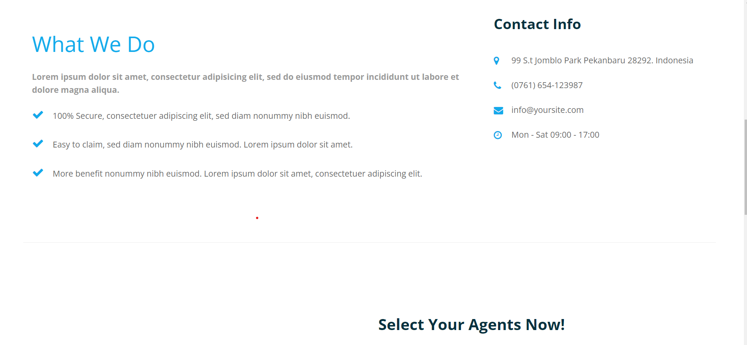

**1.7 News**

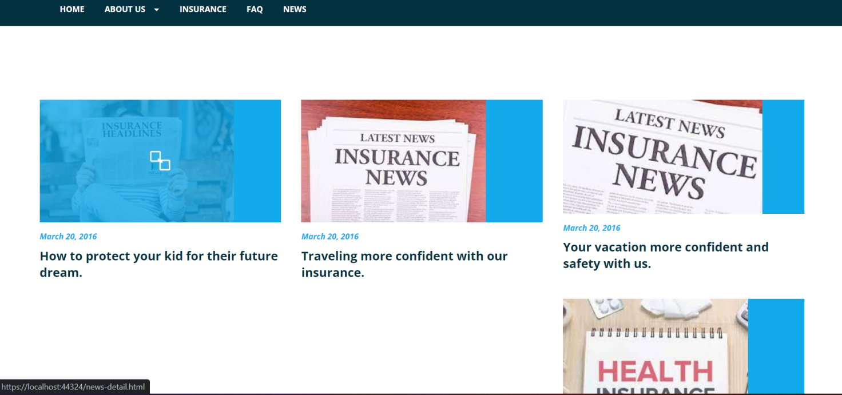

|  |  |  |  |  |  |  |
| --- | --- | --- | --- | --- | --- | --- |
| **No** | **Name** | **Type** | **Validation** | **Event** | **Description** | **Status** |
|  |  |  |  |  |  |  |
| 1 | Navigation Bar | Hyperlink |  | Click | Choose and go to pages | Enable |
|  |  |  |  |  |  |  |
| 2 | New view | Hyperlink |  | Click | Choose and go to pages | Enable |
|  |  |  |  |  |  |  |

**1.8 Policy**

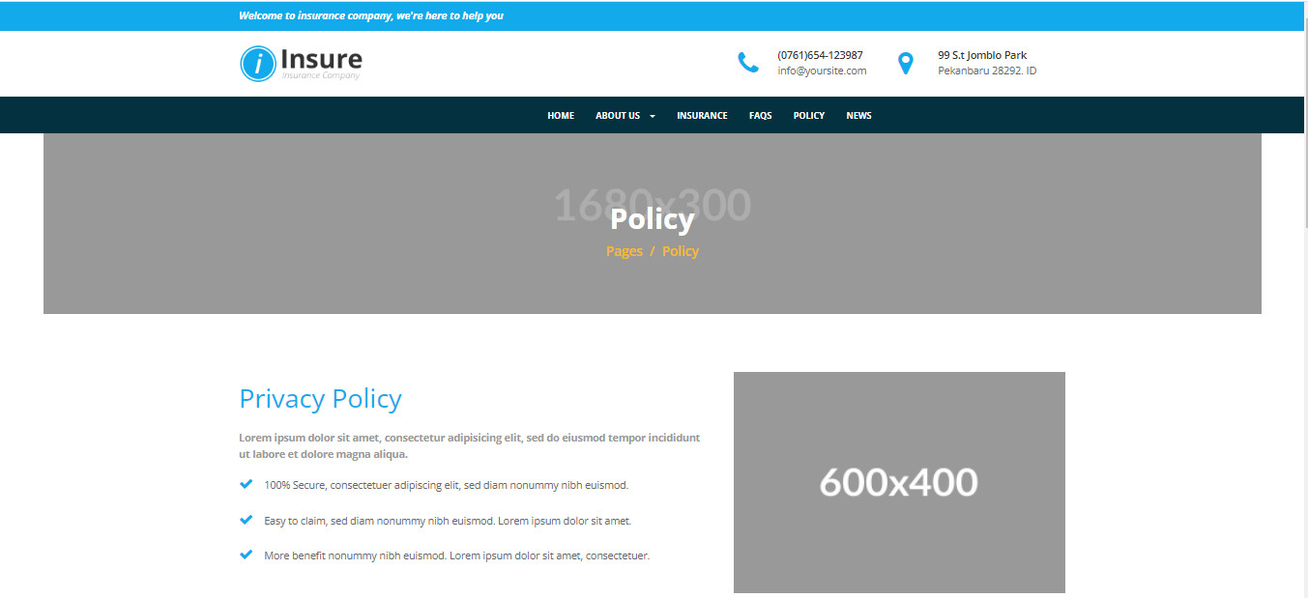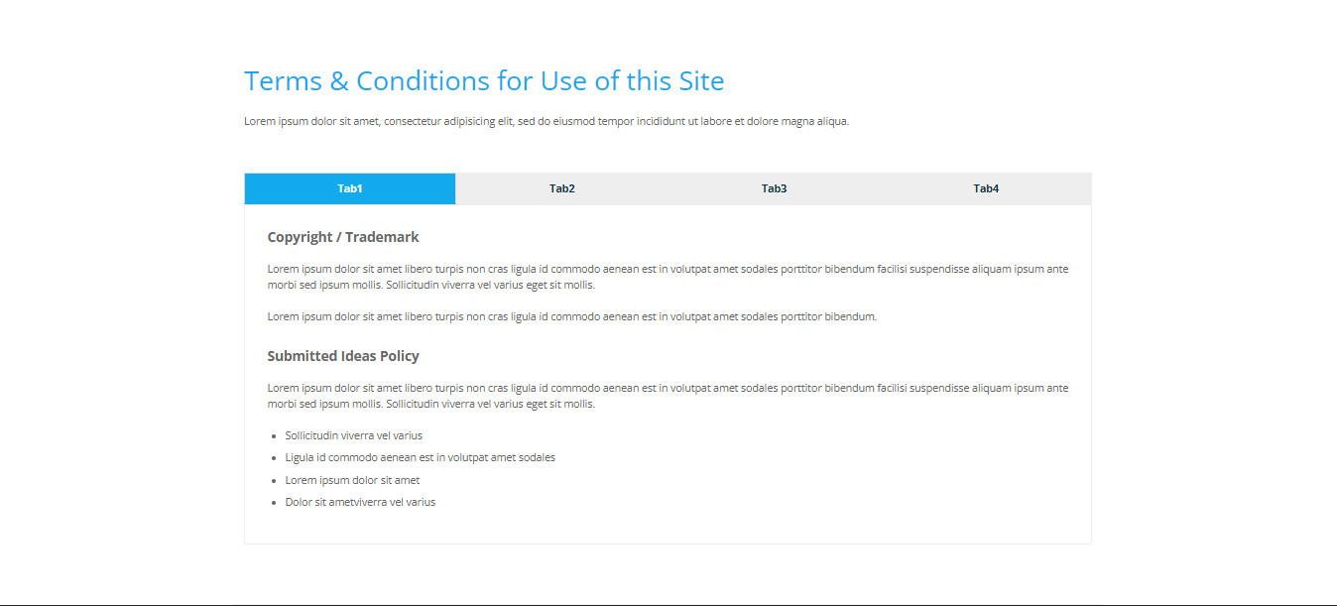

|  |  |  |  |  |  |  |
| --- | --- | --- | --- | --- | --- | --- |
| **No** | **Name** | **Type** | **Validation** | **Event** | **Description** | **Status** |
|  |  |  |  |  |  |  |
| 1 | Navigation Bar | Hyperlink |  | Click | Choose and go to pages | Enable |
|  |  |  |  |  |  |  |
| 2 | New view | Hyperlink |  | Click | Choose and go to pages | Enable |
|  |  |  |  |  |  |  |

# GUI DESIGN Back-end(Admin)

**4.1Admin Login Page**

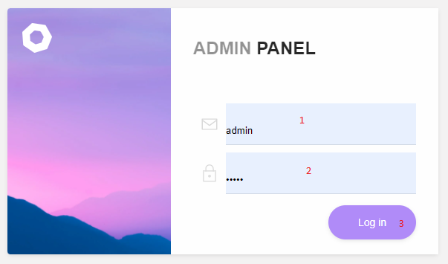

|  |  |  |  |  |  |  |
| --- | --- | --- | --- | --- | --- | --- |
| **No** | **Name** | **Type** | **Validation** | **Event** | **Description** | **Status** |
|  |  |  |  |  |  |  |
| 1 | Username | Input | Required | Focus | Admin Username | Enable |
|  |  |  |  |  |  |  |
| **2** | Password | Input | Required | Focus | Admin Password | Enable |
|  |  |  |  |  |  |  |
| **3** | Login | Button |  | Click | Login Admin Page | Enable |
|  |  |  |  |  |  |  |

**4.2Account Admin Setting and Log out**

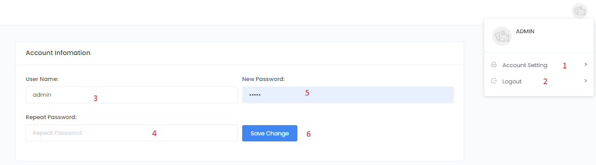

|  |  |  |  |  |  |  |
| --- | --- | --- | --- | --- | --- | --- |
| **No** | **Name** | **Type** | **Validation** | **Event** | **Description** | **Status** |
|  |  |  |  |  |  |  |
| 1 | Account Setting | Hyperlink |  | Click | Choose and go to page | Enable |
|  |  |  |  |  |  |  |
| **2** | Log Out | Hyperlink |  | Click | Log out page Admin | Enable |
|  |  |  |  |  |  |  |
| **3** | User Name | Input | Required | Focus | Input UserName | Enable |
|  |  |  |  |  |  |  |
| **4** | Repeat Password | Input | Required | Focus | Input Repeat Password | Enable |
|  |  |  |  |  |  |  |
| **5** | New Password | Inout | Required | Focus | Input New Password | Enable |
|  |  |  |  |  |  |  |
| **6** | Save Change | Button |  | Click | Save Admin Infomation | Enable |
|  |  |  |  |  |  |  |

**4.3 Insurance Manage  
 *4.3.1*. List of Insurance**

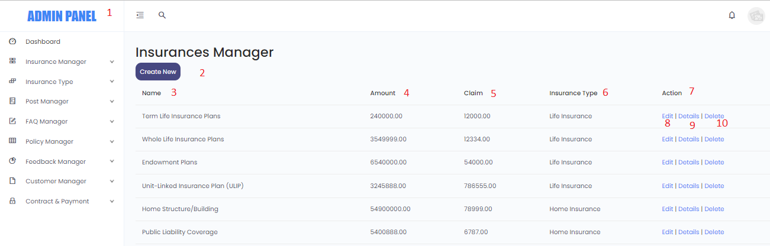

|  |  |  |  |  |  |  |  |  |  |  |  |
| --- | --- | --- | --- | --- | --- | --- | --- | --- | --- | --- | --- |
| **No** |  |  | **Name** |  | **Type** | **Validation** |  | **Event** |  | **Description** | **Status** |
|  |  |  |  |  |  |  |  |  |  |  |  |
| 1 |  |  | Navigation Bar |  | Hyperlink |  |  | Click |  | Choose and click to go to pages | Enable |
| 2 |  |  | Create new |  | Hyperlink |  |  | Click |  | Click to create a Insurance | Enable |
| 3 |  |  | Name |  | Text |  |  | Read Only |  | Insurance Name |  |
| 4 |  |  | Amount |  | Text |  |  | Read Only |  | Insurance Amount | Enable |
| 5 |  |  | Claim |  | Text |  |  | Read Only |  | Insurance Claim | Enable |
| 6 |  |  | Insurance Type |  | Text |  |  | Read Only |  | Insurance Type | Enable |
| 7 |  |  | Action |  | Text |  |  | Read Only |  | Insurance Action | Enable |
| 8 |  |  | Edit |  | Hyperlink |  |  | Click |  | Navigate to edit Insurance page | Enable |
| 9 |  |  | Details |  | Hyperlink |  |  | Click |  | Navigate to details Insurance page | Enable |
| 10 |  |  | Delete |  | Hyperlink |  |  | Click |  | Navigate to delete Insurance page | Enable |

***4.3.2*. Create Insurance**

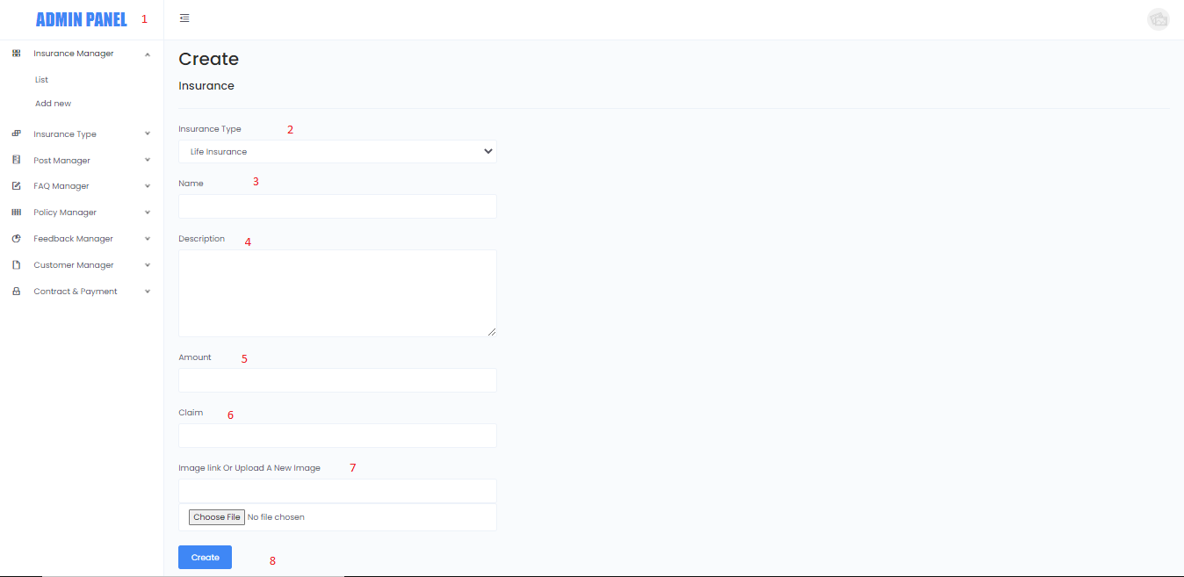

|  |  |  |  |  |  |  |  |  |  |  |  |
| --- | --- | --- | --- | --- | --- | --- | --- | --- | --- | --- | --- |
| **No** |  |  | **Name** |  | **Type** | **Validation** |  | **Event** |  | **Description** | **Status** |
|  |  |  |  |  |  |  |  |  |  |  |  |
| 1 |  |  | Navigation Bar |  | Hyperlink |  |  | Click |  | Choose and click to go to pages | Enable |
| 2 |  |  | Insurance Type |  | Combo Box |  |  | Click |  | Click to Choose Insurance Type | Enable |
| 3 |  |  | Name |  | Text |  |  | Input |  | Click to input Insurance Name |  |
| 4 |  |  | Description |  | Text |  |  | Input |  | Click to input Description | Enable |
| 5 |  |  | Amount |  | Text |  |  | Input |  | Click to input Amount | Enable |
| 6 |  |  | Claim |  | Text |  |  | Input |  | Click to input Claim | Enable |
| 7 |  |  | Image |  | File |  |  | Input |  | Click to Open File and Choose image | Enable |
| 8 |  |  | Create |  | Button |  |  | Click |  | Click to Create new Insurance and go back to Insurance page | Enable |

***4.3.3*. Edit Insurance**

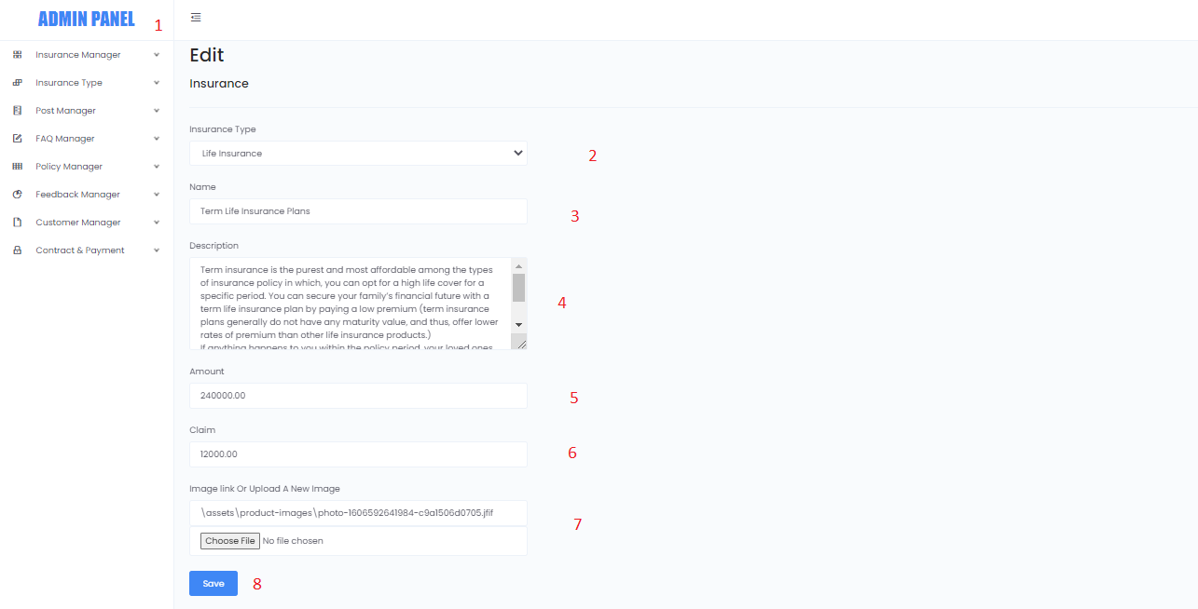

|  |  |  |  |  |  |  |  |  |  |  |  |
| --- | --- | --- | --- | --- | --- | --- | --- | --- | --- | --- | --- |
| **No** |  |  | **Name** |  | **Type** | **Validation** |  | **Event** |  | **Description** | **Status** |
|  |  |  |  |  |  |  |  |  |  |  |  |
| 1 |  |  | Navigation Bar |  | Hyperlink |  |  | Click |  | Choose and click to go to pages | Enable |
| 2 |  |  | Insurance Type |  | Combo Box |  |  | Click |  | Click to Choose Insurance Type | Enable |
| 3 |  |  | Name |  | Text |  |  | Input |  | Click to input Insurance Name |  |
| 4 |  |  | Description |  | Text |  |  | Input |  | Click to input Description | Enable |
| 5 |  |  | Amount |  | Text |  |  | Input |  | Click to input Amount | Enable |
| 6 |  |  | Claim |  | Text |  |  | Input |  | Click to input Claim | Enable |
| 7 |  |  | Image |  | File |  |  | Input |  | Click to Open File and Choose image | Enable |
| 8 |  |  | Save |  | Button |  |  | Click |  | Click to Edit Insurance and go back to Insurance page | Enable |

***4.3.4*. Delete Insurance**

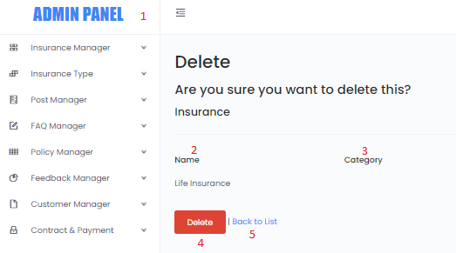

|  |  |  |  |  |  |  |  |  |  |  |  |
| --- | --- | --- | --- | --- | --- | --- | --- | --- | --- | --- | --- |
| **No** |  |  | **Name** |  | **Type** | **Validation** |  | **Event** |  | **Description** | **Status** |
|  |  |  |  |  |  |  |  |  |  |  |  |
| 1 |  |  | Navigation Bar |  | Hyperlink |  |  | Click |  | Choose and click to go to pages | Enable |
| 2 |  |  | Name |  | Text |  |  | Read Only |  | Name | Enable |
| 3 |  |  | Category |  | Text |  |  | Read Only |  | Categoty | Enable |
| 4 |  |  | Delete |  | Button |  |  | Click |  | Click to Delete Insurance and go back to Insurance page | Enable |
| 5 |  |  | Back to List |  | HyperLink |  |  | Click |  | Back to Insurance page | Enable |

* 1. **Insurance Type Manage**

***4.4.1*. List of Insurance Type**

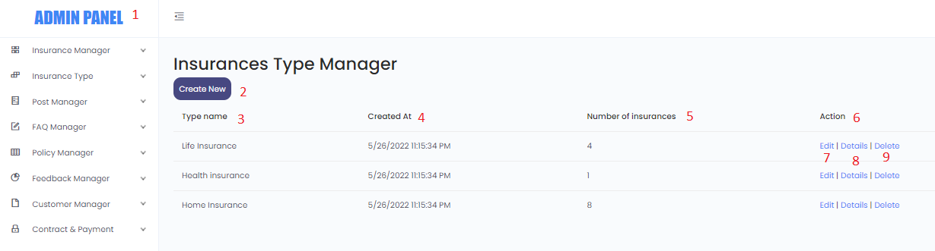

|  |  |  |  |  |  |  |  |  |  |  |  |
| --- | --- | --- | --- | --- | --- | --- | --- | --- | --- | --- | --- |
| **No** |  |  | **Name** |  | **Type** | **Validation** |  | **Event** |  | **Description** | **Status** |
|  |  |  |  |  |  |  |  |  |  |  |  |
| 1 |  |  | Navigation Bar |  | Hyperlink |  |  | Click |  | Choose and click to go to pages | Enable |
| 2 |  |  | Create new |  | Hyperlink |  |  | Click |  | Click to create a Insurance Type | Enable |
| 3 |  |  | Type Name |  | Text |  |  | Read Only |  | Insurance Type Name | Enable |
| 4 |  |  | Created_at |  | Text |  |  | Read Only |  | Insurance Type Date Created | Enable |
| 5 |  |  | Number Of Insurance |  | Text |  |  | Read Only |  | Number of Insurance | Enable |
| 6 |  |  | Action |  | Text |  |  | Read Only |  | Insurance Action | Enable |
| 7 |  |  | Edit |  | Hyperlink |  |  | Click |  | Navigate to edit Insurance type page | Enable |
| 8 |  |  | Details |  | Hyperlink |  |  | Click |  | Navigate to details Insurance page | Enable |
| 9 |  |  | Delete |  | Hyperlink |  |  | Click |  | Navigate to delete Insurance page | Enable |

***4.4.2*. Create Insurance Type**

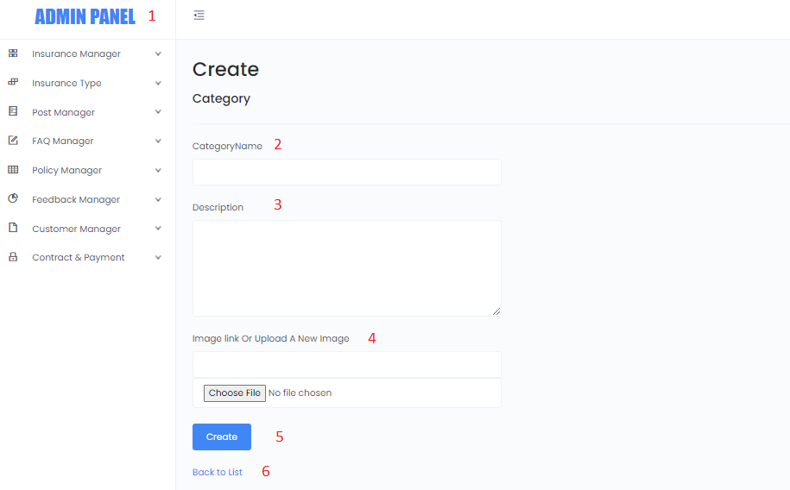

|  |  |  |  |  |  |  |  |  |  |  |  |
| --- | --- | --- | --- | --- | --- | --- | --- | --- | --- | --- | --- |
| **No** |  |  | **Name** |  | **Type** | **Validation** |  | **Event** |  | **Description** | **Status** |
|  |  |  |  |  |  |  |  |  |  |  |  |
| 1 |  |  | Navigation Bar |  | Hyperlink |  |  | Click |  | Choose and click to go to pages | Enable |
| 2 |  |  | Category Name |  | Text |  |  | Input |  | Input Category Name | Enable |
| 3 |  |  | Description |  | Text |  |  | Input |  | Input Description | Enable |
| 4 |  |  | Image |  | File |  |  | Input |  | Click to choose input Image | Enable |
| 5 |  |  | Create |  | Button |  |  | Input |  | Click to Create Insurance type | Enable |
| 6 |  |  | Back to list |  | Hyperlink |  |  | Input |  | Click to Back to list Insurance Type | Enable |

***4.4.3*. Edit Insurance Type**

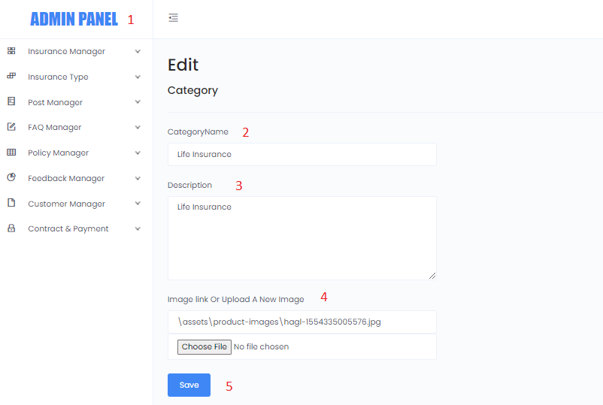

|  |  |  |  |  |  |  |  |  |  |  |  |
| --- | --- | --- | --- | --- | --- | --- | --- | --- | --- | --- | --- |
| **No** |  |  | **Name** |  | **Type** | **Validation** |  | **Event** |  | **Description** | **Status** |
|  |  |  |  |  |  |  |  |  |  |  |  |
| 1 |  |  | Navigation Bar |  | Hyperlink |  |  | Click |  | Choose and click to go to pages | Enable |
| 2 |  |  | Category Name |  | Text |  |  | Input |  | Input Category Name | Enable |
| 3 |  |  | Description |  | Text |  |  | Input |  | Input Description | Enable |
| 4 |  |  | Image |  | File |  |  | Input |  | Click to choose input Image | Enable |
| 5 |  |  | Save |  | Button |  |  | Input |  | Click to Save Insurance type | Enable |

***4.4.4*. Delete Insurance Type**

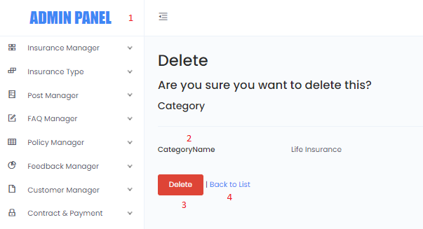

|  |  |  |  |  |  |  |  |  |  |  |  |
| --- | --- | --- | --- | --- | --- | --- | --- | --- | --- | --- | --- |
| **No** |  |  | **Name** |  | **Type** | **Validation** |  | **Event** |  | **Description** | **Status** |
|  |  |  |  |  |  |  |  |  |  |  |  |
| 1 |  |  | Navigation Bar |  | Hyperlink |  |  | Click |  | Choose and click to go to pages | Enable |
| 2 |  |  | Category Name |  | Text |  |  | Read Only |  | Category Name | Enable |
| 3 |  |  | Delete |  | Button |  |  | Read Only |  | Delete Insurance type | Enable |
| 4 |  |  | Back to list |  | Hyperlink |  |  | Click |  | Click and back to list Insurance Type | Enable |

* 1. **Post Manage  
      *4.5*.1 List of Post**

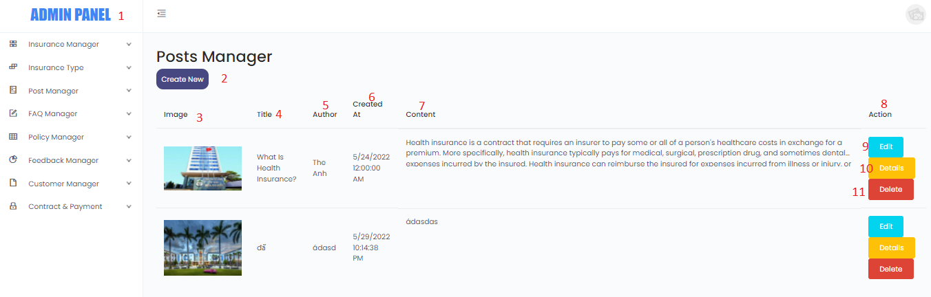

|  |  |  |  |  |  |  |  |  |  |  |  |
| --- | --- | --- | --- | --- | --- | --- | --- | --- | --- | --- | --- |
| **No** |  |  | **Name** |  | **Type** | **Validation** |  | **Event** |  | **Description** | **Status** |
|  |  |  |  |  |  |  |  |  |  |  |  |
| 1 |  |  | Navigation Bar |  | Hyperlink |  |  | Click |  | Choose and click to go to pages | Enable |
| 2 |  |  | Create new |  | Hyperlink |  |  | Click |  | Click to create a Post | Enable |
| 3 |  |  | Image |  | Text |  |  | Read Only |  | Post Image | Enable |
| 4 |  |  | Title |  | Text |  |  | Read Only |  | Post Title | Enable |
| 5 |  |  | Author |  | Text |  |  | Read Only |  | Post Author | Enable |
| 6 |  |  | Create_at |  | Text |  |  | Read Only |  | Post Created Date | Enable |
| 7 |  |  | Content |  | Text |  |  | Read Only |  | Post Content | Enable |
| 8 |  |  | Action |  | Text |  |  | Read Only |  | Post Action | Enable |
| 9 |  |  | Edit |  | Hyperlink |  |  | Click |  | Navigate to edit Post type page | Enable |
| 10 |  |  | Details |  | Hyperlink |  |  | Click |  | Navigate to details Post page | Enable |
| 11 |  |  | Delete |  | Hyperlink |  |  | Click |  | Navigate to delete Post page | Enable |

***4.5*.2 Create Post**

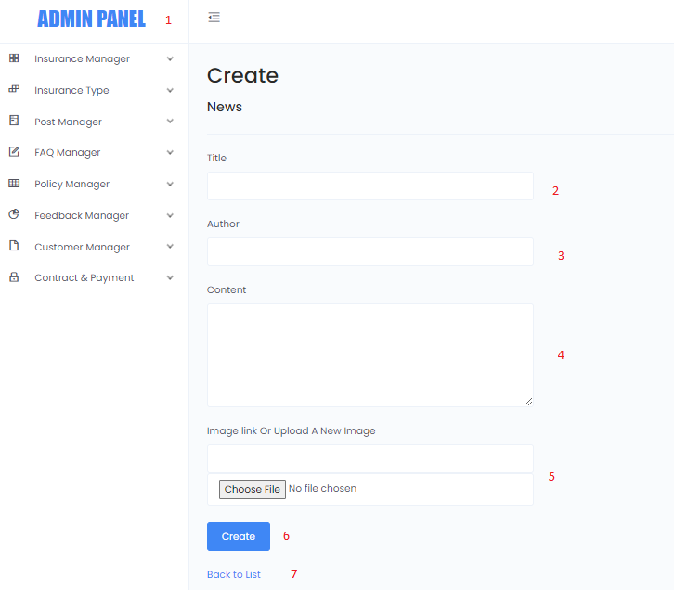

|  |  |  |  |  |  |  |  |  |  |  |  |
| --- | --- | --- | --- | --- | --- | --- | --- | --- | --- | --- | --- |
| **No** |  |  | **Name** |  | **Type** | **Validation** |  | **Event** |  | **Description** | **Status** |
|  |  |  |  |  |  |  |  |  |  |  |  |
| 1 |  |  | Navigation Bar |  | Hyperlink |  |  | Click |  | Choose and click to go to pages | Enable |
| 2 |  |  | Title |  | Text |  |  | Input |  | Input Title | Enable |
| 3 |  |  | Author |  | Text |  |  | Input |  | Input Author | Enable |
| 4 |  |  | Content |  | Text |  |  | Input |  | Input Content | Enable |
| 5 |  |  | Image |  | File |  |  | Input |  | Click to choose input Image | Enable |
| 6 |  |  | Create |  | Button |  |  | Input |  | Click to Create Post type | Enable |
| 7 |  |  | Back to list |  | Hyperlink |  |  | Input |  | Click to Back to list Post | Enable |

***4.5*.3 Edit Post**

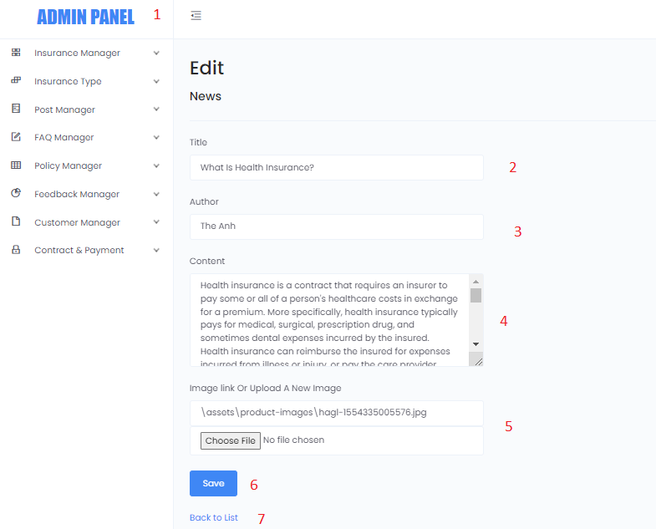

|  |  |  |  |  |  |  |  |  |  |  |  |
| --- | --- | --- | --- | --- | --- | --- | --- | --- | --- | --- | --- |
| **No** |  |  | **Name** |  | **Type** | **Validation** |  | **Event** |  | **Description** | **Status** |
|  |  |  |  |  |  |  |  |  |  |  |  |
| 1 |  |  | Navigation Bar |  | Hyperlink |  |  | Click |  | Choose and click to go to pages | Enable |
| 2 |  |  | Title |  | Text |  |  | Input |  | Input Title | Enable |
| 3 |  |  | Author |  | Text |  |  | Input |  | Input Author | Enable |
| 4 |  |  | Content |  | Text |  |  | Input |  | Input Content | Enable |
| 5 |  |  | Image |  | File |  |  | Input |  | Click to choose input Image | Enable |
| 6 |  |  | Save |  | Button |  |  | Input |  | Click to Save Post | Enable |
| 7 |  |  | Back to list |  | Hyperlink |  |  | Input |  | Click to Back to list Post | Enable |

***4.5*.4 Delete Post**

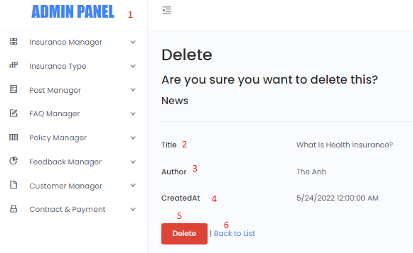

|  |  |  |  |  |  |  |  |  |  |  |  |
| --- | --- | --- | --- | --- | --- | --- | --- | --- | --- | --- | --- |
| **No** |  |  | **Name** |  | **Type** | **Validation** |  | **Event** |  | **Description** | **Status** |
|  |  |  |  |  |  |  |  |  |  |  |  |
| 1 |  |  | Navigation Bar |  | Hyperlink |  |  | Click |  | Choose and click to go to pages | Enable |
| 2 |  |  | Title |  | Text |  |  | Read Only |  | Post Title | Enable |
| 3 |  |  | Author |  | Text |  |  | Read Only |  | Post Author | Enable |
| 4 |  |  | CreatedAt |  | Text |  |  | Read Only |  | Post CreatedAt | Enable |
| 5 |  |  | Delete |  | Button |  |  | Read Only |  | Delete Post | Enable |
| 6 |  |  | Back to list |  | Hyperlink |  |  | Click |  | Click and back to list Post | Enable |

* 1. **FAQs Manager  
      *4.6*.1 List of FAQs Question**

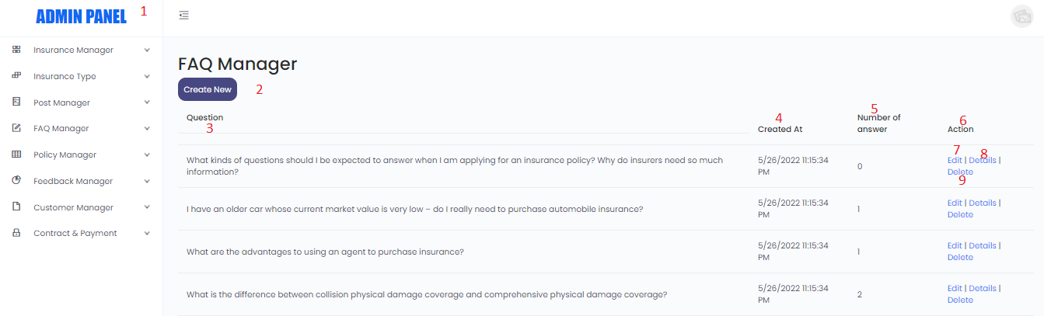

|  |  |  |  |  |  |  |  |  |  |  |  |
| --- | --- | --- | --- | --- | --- | --- | --- | --- | --- | --- | --- |
| **No** |  |  | **Name** |  | **Type** | **Validation** |  | **Event** |  | **Description** | **Status** |
|  |  |  |  |  |  |  |  |  |  |  |  |
| 1 |  |  | Navigation Bar |  | Hyperlink |  |  | Click |  | Choose and click to go to pages | Enable |
| 2 |  |  | Create new |  | Hyperlink |  |  | Click |  | Click to create a FAQs | Enable |
| 3 |  |  | Question |  | Text |  |  | Read Only |  | FAQs Image | Enable |
| 4 |  |  | Create_at |  | Text |  |  | Read Only |  | FAQs Title | Enable |
| 5 |  |  | Number of Answer |  | Text |  |  | Read Only |  | FAQs Content | Enable |
| 6 |  |  | Action |  | Text |  |  | Read Only |  | FAQs Action | Enable |
| 7 |  |  | Edit |  | Hyperlink |  |  | Click |  | Navigate to edit FAQs type page | Enable |
| 8 |  |  | Details |  | Hyperlink |  |  | Click |  | Navigate to details FAQs page | Enable |
| 9 |  |  | Delete |  | Hyperlink |  |  | Click |  | Navigate to delete FAQs page | Enable |

***4.6*.2 Create FAQs Question**

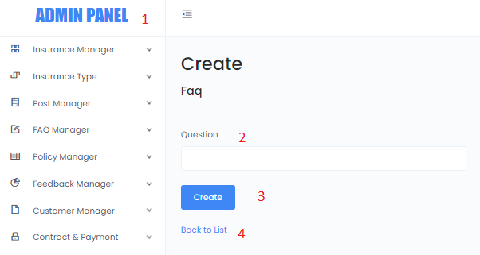

|  |  |  |  |  |  |  |  |  |  |  |  |
| --- | --- | --- | --- | --- | --- | --- | --- | --- | --- | --- | --- |
| **No** |  |  | **Name** |  | **Type** | **Validation** |  | **Event** |  | **Description** | **Status** |
|  |  |  |  |  |  |  |  |  |  |  |  |
| 1 |  |  | Navigation Bar |  | Hyperlink |  |  | Click |  | Choose and click to go to pages | Enable |
| 2 |  |  | Question |  | Input |  |  | Input |  | Input FAQs Question | Enable |
| 3 |  |  | Create |  | Button |  |  | Click |  | Create FAQs Question | Enable |
| 4 |  |  | Back to list |  | Hyperlink |  |  | Click |  | Click and go back to list FAQs Question | Enable |

***4.6*.3 Edit FAQs Question**

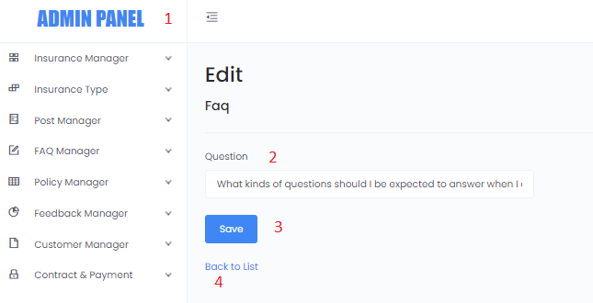

|  |  |  |  |  |  |  |  |  |  |  |  |
| --- | --- | --- | --- | --- | --- | --- | --- | --- | --- | --- | --- |
| **No** |  |  | **Name** |  | **Type** | **Validation** |  | **Event** |  | **Description** | **Status** |
|  |  |  |  |  |  |  |  |  |  |  |  |
| 1 |  |  | Navigation Bar |  | Hyperlink |  |  | Click |  | Choose and click to go to pages | Enable |
| 2 |  |  | Question |  | Input |  |  | Input |  | Input FAQs Question | Enable |
| 3 |  |  | Save |  | Button |  |  | Click |  | Save FAQs Question | Enable |
| 4 |  |  | Back to list |  | Hyperlink |  |  | Click |  | Click and go back to list FAQs Question | Enable |

***4.6*.4 Delete FAQs Question**

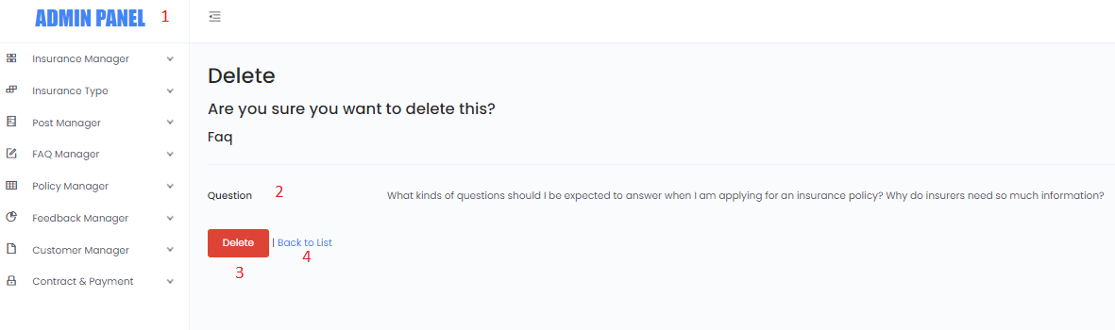

|  |  |  |  |  |  |  |  |  |  |  |  |
| --- | --- | --- | --- | --- | --- | --- | --- | --- | --- | --- | --- |
| **No** |  |  | **Name** |  | **Type** | **Validation** |  | **Event** |  | **Description** | **Status** |
|  |  |  |  |  |  |  |  |  |  |  |  |
| 1 |  |  | Navigation Bar |  | Hyperlink |  |  | Click |  | Choose and click to go to pages | Enable |
| 2 |  |  | Question |  | Text |  |  | Read Only |  | FAQs Question | Enable |
| 3 |  |  | Delete |  | Button |  |  | Click |  | Delete FAQs Question | Enable |
| 4 |  |  | Back to list |  | Hyperlink |  |  | Click |  | Click and go back to list FAQs Question | Enable |

***4.6*.5 List of FAQs Reply**

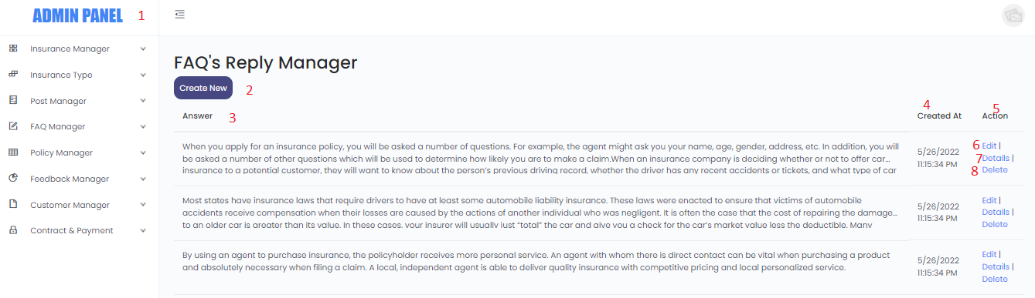

|  |  |  |  |  |  |  |  |  |  |  |  |
| --- | --- | --- | --- | --- | --- | --- | --- | --- | --- | --- | --- |
| **No** |  |  | **Name** |  | **Type** | **Validation** |  | **Event** |  | **Description** | **Status** |
|  |  |  |  |  |  |  |  |  |  |  |  |
| 1 |  |  | Navigation Bar |  | Hyperlink |  |  | Click |  | Choose and click to go to pages | Enable |
| 2 |  |  | Create new |  | Hyperlink |  |  | Click |  | Click to create a FAQs Reply | Enable |
| 3 |  |  | Answer |  | Text |  |  | Read Only |  | FAQs Answer | Enable |
| 4 |  |  | Create_at |  | Text |  |  | Read Only |  | FAQs Created date | Enable |
| 5 |  |  | Action |  | Text |  |  | Read Only |  | FAQs Action | Enable |
| 6 |  |  | Edit |  | Hyperlink |  |  | Click |  | Navigate to edit FAQs Reply page | Enable |
| 7 |  |  | Details |  | Hyperlink |  |  | Click |  | Navigate to details FAQs Reply page | Enable |
| 8 |  |  | Delete |  | Hyperlink |  |  | Click |  | Navigate to delete FAQs Reply page | Enable |

***4.6*.6 Create FAQs Reply**

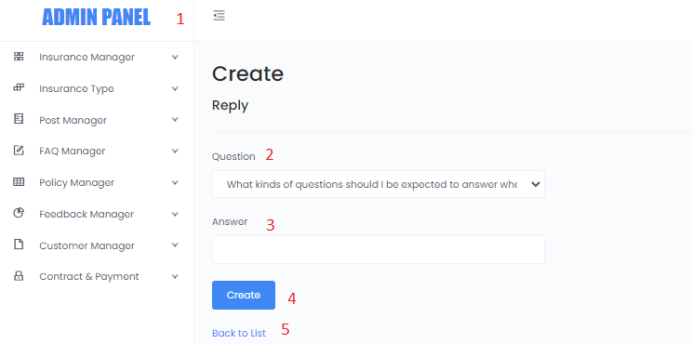

|  |  |  |  |  |  |  |  |  |  |  |  |
| --- | --- | --- | --- | --- | --- | --- | --- | --- | --- | --- | --- |
| **No** |  |  | **Name** |  | **Type** | **Validation** |  | **Event** |  | **Description** | **Status** |
|  |  |  |  |  |  |  |  |  |  |  |  |
| 1 |  |  | Navigation Bar |  | Hyperlink |  |  | Click |  | Choose and click to go to pages | Enable |
| 2 |  |  | Question |  | Combo box |  |  | Click |  | Cick and choose FAQs Question | Enable |
| 3 |  |  | Answer |  | Text |  |  | Input |  | Inpunt FAQs Answer | Enable |
| 4 |  |  | Create |  | Button |  |  | Click |  | Create FAQs Answer | Enable |
| 5 |  |  | Back to list |  | Hyperlink |  |  | Click |  | Click and go back to list FAQs Answer | Enable |

***4.6*.7 Edit FAQs Reply**

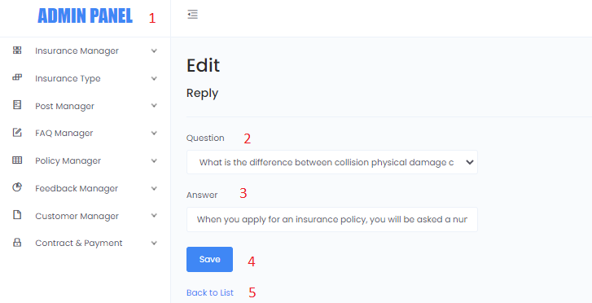

|  |  |  |  |  |  |  |  |  |  |  |  |
| --- | --- | --- | --- | --- | --- | --- | --- | --- | --- | --- | --- |
| **No** |  |  | **Name** |  | **Type** | **Validation** |  | **Event** |  | **Description** | **Status** |
|  |  |  |  |  |  |  |  |  |  |  |  |
| 1 |  |  | Navigation Bar |  | Hyperlink |  |  | Click |  | Choose and click to go to pages | Enable |
| 2 |  |  | Question |  | Combo box |  |  | Click |  | Cick and choose FAQs Question | Enable |
| 3 |  |  | Answer |  | Text |  |  | Input |  | Inpunt FAQs Answer | Enable |
| 4 |  |  | Save |  | Button |  |  | Click |  | Save FAQs Answer | Enable |
| 5 |  |  | Back to list |  | Hyperlink |  |  | Click |  | Click and go back to list FAQs Answer | Enable |

***4.6*.8 Delete FAQs Reply**

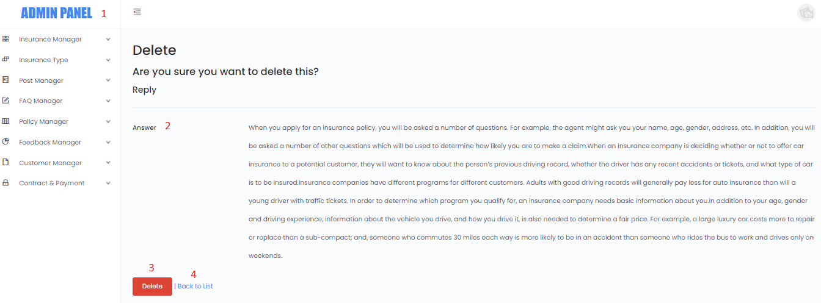

|  |  |  |  |  |  |  |  |  |  |  |  |
| --- | --- | --- | --- | --- | --- | --- | --- | --- | --- | --- | --- |
| **No** |  |  | **Name** |  | **Type** | **Validation** |  | **Event** |  | **Description** | **Status** |
|  |  |  |  |  |  |  |  |  |  |  |  |
| 1 |  |  | Navigation Bar |  | Hyperlink |  |  | Click |  | Choose and click to go to pages | Enable |
| 2 |  |  | Answer |  | Text |  |  | Read Only |  | Reply Answer | Enable |
| 3 |  |  | Delete |  | Button |  |  | Click |  | Delete FAQs Answer | Enable |
| 4 |  |  | Back to list |  | Hyperlink |  |  | Click |  | Click and go back to list FAQs Answer | Enable |

**4.7 Policy Manage  
*4.7.*1. List of Policy**

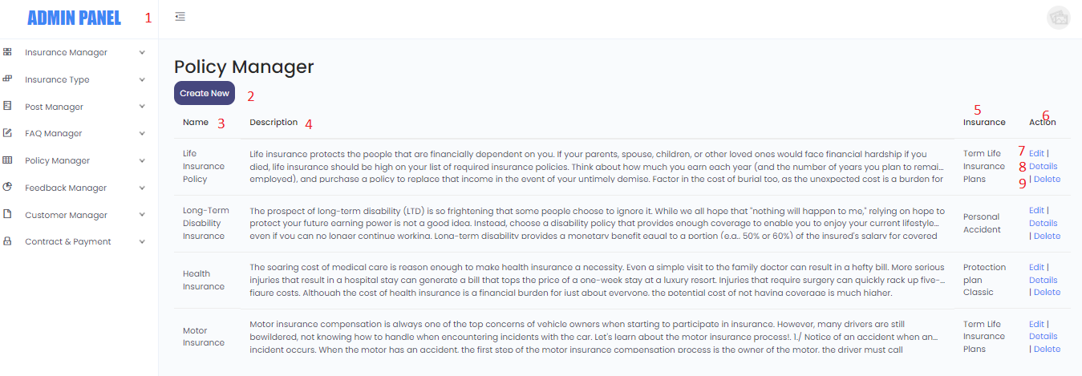

|  |  |  |  |  |  |  |  |  |  |  |  |
| --- | --- | --- | --- | --- | --- | --- | --- | --- | --- | --- | --- |
| **No** |  |  | **Name** |  | **Type** | **Validation** |  | **Event** |  | **Description** | **Status** |
|  |  |  |  |  |  |  |  |  |  |  |  |
| 1 |  |  | Navigation Bar |  | Hyperlink |  |  | Click |  | Choose and click to go to pages | Enable |
| 2 |  |  | Create new |  | Hyperlink |  |  | Click |  | Click to create a FAQs Reply | Enable |
| 3 |  |  | Name |  | Text |  |  | Read Only |  | Policy Name | Enable |
| 4 |  |  | Description |  | Text |  |  | Read Only |  | Policy Description | Enable |
| 5 |  |  | Insurance |  | Text |  |  | Read Only |  | Insurance type | Enable |
| 6 |  |  | Action |  | Text |  |  | Read Only |  | Policy Action | Enable |
| 7 |  |  | Edit |  | Hyperlink |  |  | Click |  | Navigate to edit Policy page | Enable |
| 8 |  |  | Details |  | Hyperlink |  |  | Click |  | Navigate to details Policy page | Enable |
| 9 |  |  | Delete |  | Hyperlink |  |  | Click |  | Navigate to delete Policy page | Enable |

***4.7.*2. Create Policy**

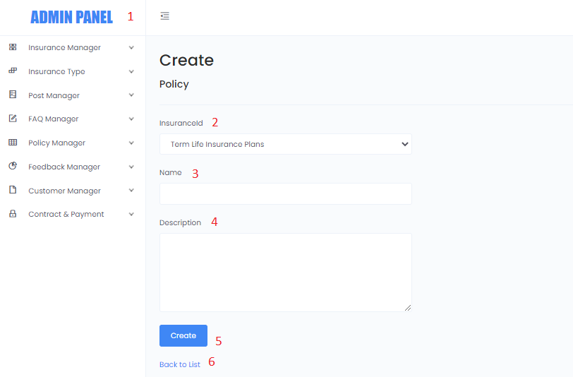

|  |  |  |  |  |  |  |  |  |  |  |  |
| --- | --- | --- | --- | --- | --- | --- | --- | --- | --- | --- | --- |
| **No** |  |  | **Name** |  | **Type** | **Validation** |  | **Event** |  | **Description** | **Status** |
|  |  |  |  |  |  |  |  |  |  |  |  |
| 1 |  |  | Navigation Bar |  | Hyperlink |  |  | Click |  | Choose and click to go to pages | Enable |
| 2 |  |  | Insurance ID |  | Combo Box |  |  | Click |  | Click to Choose Insurance Type | Enable |
| 3 |  |  | Name |  | Text |  |  | Input |  | Click to input Insurance Name | Enable |
| 4 |  |  | Description |  | Text |  |  | Input |  | Click to input Description | Enable |
| 5 |  |  | Create |  | Button |  |  | Click |  | Click to Create new Policy | Enable |
| 6 |  |  | Back to List |  | Hyperlink |  |  | Click |  | Click and back to Policy list page | Enable |

***4.7.*3. Edit Policy**

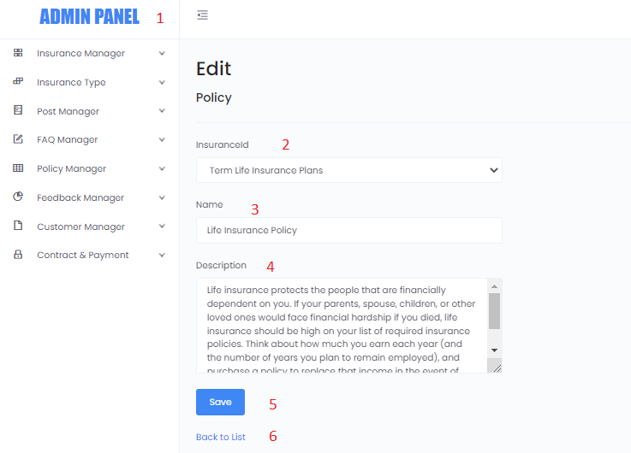

|  |  |  |  |  |  |  |  |  |  |  |  |
| --- | --- | --- | --- | --- | --- | --- | --- | --- | --- | --- | --- |
| **No** |  |  | **Name** |  | **Type** | **Validation** |  | **Event** |  | **Description** | **Status** |
|  |  |  |  |  |  |  |  |  |  |  |  |
| 1 |  |  | Navigation Bar |  | Hyperlink |  |  | Click |  | Choose and click to go to pages | Enable |
| 2 |  |  | Insurance ID |  | Combo Box |  |  | Click |  | Click to Choose Insurance Type | Enable |
| 3 |  |  | Name |  | Text |  |  | Input |  | Click to input Insurance Name | Enable |
| 4 |  |  | Description |  | Text |  |  | Input |  | Click to input Description | Enable |
| 5 |  |  | Save |  | Button |  |  | Click |  | Click to Save Policy | Enable |
| 6 |  |  | Back to List |  | Hyperlink |  |  | Click |  | Click and back to Policy list page | Enable |

***4.7.*4. Delete Policy**

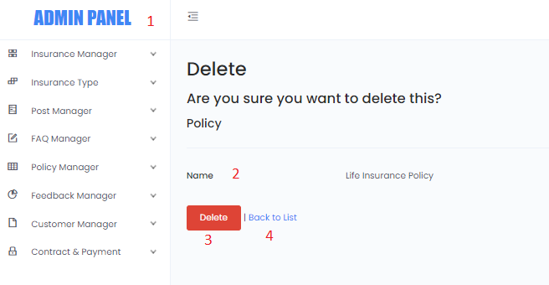

|  |  |  |  |  |  |  |  |  |  |  |  |
| --- | --- | --- | --- | --- | --- | --- | --- | --- | --- | --- | --- |
| **No** |  |  | **Name** |  | **Type** | **Validation** |  | **Event** |  | **Description** | **Status** |
|  |  |  |  |  |  |  |  |  |  |  |  |
| 1 |  |  | Navigation Bar |  | Hyperlink |  |  | Click |  | Choose and click to go to pages | Enable |
| 2 |  |  | Name |  | Text |  |  | Read Only |  | Policy Nam | Enable |
| 3 |  |  | Delete |  | Button |  |  | Click |  | Delete Policy | Enable |
| 4 |  |  | Back to list |  | Hyperlink |  |  | Click |  | Click and go back to list Policy | Enable |

**4.8 Feeback Manager  
*4.8.*1*.* List of Feedback**

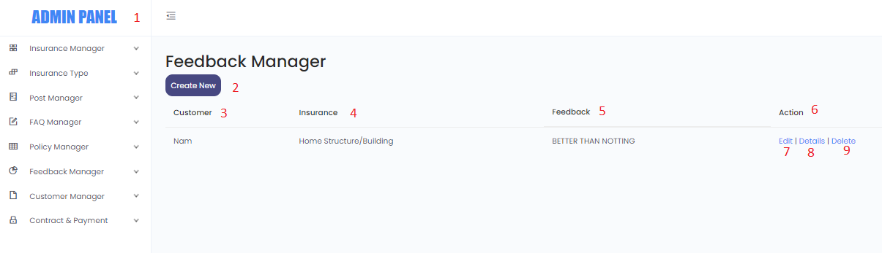

|  |  |  |  |  |  |  |  |  |  |  |  |
| --- | --- | --- | --- | --- | --- | --- | --- | --- | --- | --- | --- |
| **No** |  |  | **Name** |  | **Type** | **Validation** |  | **Event** |  | **Description** | **Status** |
|  |  |  |  |  |  |  |  |  |  |  |  |
| 1 |  |  | Navigation Bar |  | Hyperlink |  |  | Click |  | Choose and click to go to pages | Enable |
| 2 |  |  | Create new |  | Hyperlink |  |  | Click |  | Click to create a FAQs Reply | Enable |
| 3 |  |  | Customer |  | Text |  |  | Read Only |  | Customer Name | Enable |
| 4 |  |  | Insurance |  | Text |  |  | Read Only |  | Insurance Type | Enable |
| 5 |  |  | Feedback |  | Text |  |  | Read Only |  | Feedback Content | Enable |
| 6 |  |  | Action |  | Text |  |  | Read Only |  | Feedback Action | Enable |
| 7 |  |  | Edit |  | Hyperlink |  |  | Click |  | Navigate to edit Feedback page | Enable |
| 8 |  |  | Details |  | Hyperlink |  |  | Click |  | Navigate to details Feedback page | Enable |
| 9 |  |  | Delete |  | Hyperlink |  |  | Click |  | Navigate to delete Feedback page | Enable |

***4.8.*2*.* Create Feedback**

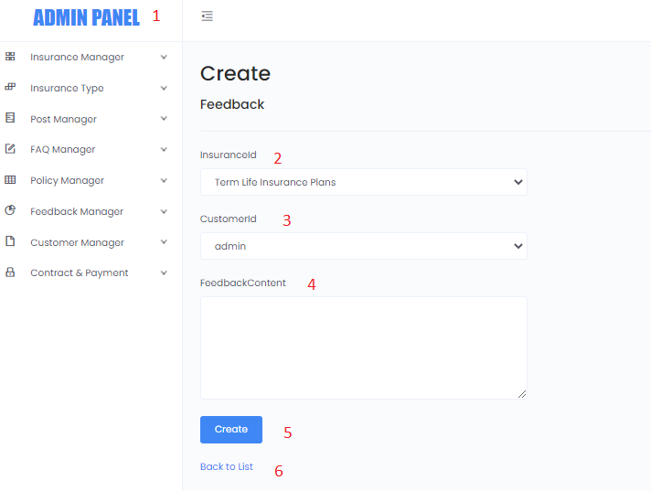

|  |  |  |  |  |  |  |  |  |  |  |  |
| --- | --- | --- | --- | --- | --- | --- | --- | --- | --- | --- | --- |
| **No** |  |  | **Name** |  | **Type** | **Validation** |  | **Event** |  | **Description** | **Status** |
|  |  |  |  |  |  |  |  |  |  |  |  |
| 1 |  |  | Navigation Bar |  | Hyperlink |  |  | Click |  | Choose and click to go to pages | Enable |
| 2 |  |  | Insurance ID |  | Combo Box |  |  | Click |  | Click to Choose Insurance Type | Enable |
| 3 |  |  | Customer ID |  | Combo Box |  |  | Click |  | Click to input Insurance Name | Enable |
| 4 |  |  | Feedback Content |  | Text |  |  | Input |  | Click to input Content | Enable |
| 5 |  |  | Create |  | Button |  |  | Click |  | Click to Create new Feedback | Enable |
| 6 |  |  | Back to List |  | Hyperlink |  |  | Click |  | Click and back to Feedback list page | Enable |

***4.8.*3*.* Edit Feedback**



|  |  |  |  |  |  |  |  |  |  |  |  |
| --- | --- | --- | --- | --- | --- | --- | --- | --- | --- | --- | --- |
| **No** |  |  | **Name** |  | **Type** | **Validation** |  | **Event** |  | **Description** | **Status** |
|  |  |  |  |  |  |  |  |  |  |  |  |
| 1 |  |  | Navigation Bar |  | Hyperlink |  |  | Click |  | Choose and click to go to pages | Enable |
| 2 |  |  | Question |  | Combo Box |  |  | Click |  | Click to Choose Question | Enable |
| 3 |  |  | Asnwer |  | Text |  |  | Input |  | Click to input Answer | Enable |
| 4 |  |  | Feedback Content |  | Text |  |  | Input |  | Click to input Content | Enable |
| 5 |  |  | Save |  | Button |  |  | Click |  | Click to Save Feedback | Enable |
| 6 |  |  | Back to List |  | Hyperlink |  |  | Click |  | Click and back to Feedback list page | Enable |

***4.8.*4*.* Detail Feedback**

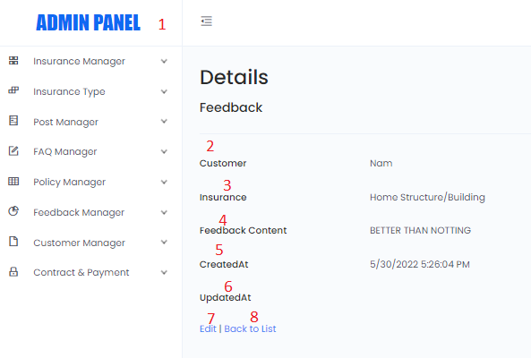

|  |  |  |  |  |  |  |  |  |  |  |  |
| --- | --- | --- | --- | --- | --- | --- | --- | --- | --- | --- | --- |
| **No** |  |  | **Name** |  | **Type** | **Validation** |  | **Event** |  | **Description** | **Status** |
|  |  |  |  |  |  |  |  |  |  |  |  |
| 1 |  |  | Navigation Bar |  | Text |  |  | Read Only |  | Choose and click to go to pages | Enable |
| 2 |  |  | Customer |  | Text |  |  | Read Only |  | Customer Name | Enable |
| 3 |  |  | Insurance |  | Text |  |  | Read Only |  | Insurance type | Enable |
| 4 |  |  | Feedback Content |  | Text |  |  | Read Only |  | Feedback Content | Enable |
| 5 |  |  | Created At |  | Text |  |  | Read Only |  | Created date | Enable |
| 6 |  |  | Updated At |  |  |  |  |  |  |  |  |
| 7 |  |  | Edit |  | Text |  |  | Read Only |  | Click to Edit Feedbacl | Enable |
| 8 |  |  | Back to List |  | Text |  |  | Read Only |  | Click and back to Feedback list page | Enable |

***4.8.*5*.* Delete Feedback**

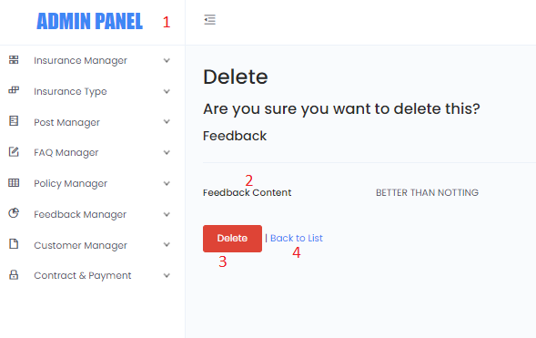

|  |  |  |  |  |  |  |  |  |  |  |  |
| --- | --- | --- | --- | --- | --- | --- | --- | --- | --- | --- | --- |
| **No** |  |  | **Name** |  | **Type** | **Validation** |  | **Event** |  | **Description** | **Status** |
|  |  |  |  |  |  |  |  |  |  |  |  |
| 1 |  |  | Navigation Bar |  | Hyperlink |  |  | Click |  | Choose and click to go to pages | Enable |
| 2 |  |  | Feedback Content |  | Text |  |  | Read Only |  | Feedback Content | Enable |
| 3 |  |  | Delete |  | Button |  |  | Click |  | Delete Feedback | Enable |
| 4 |  |  | Back to list |  | Hyperlink |  |  | Click |  | Click and go back to list Feedback | Enable |

**4.9 Customer Manager**

***4.9*.1. List of Customer**

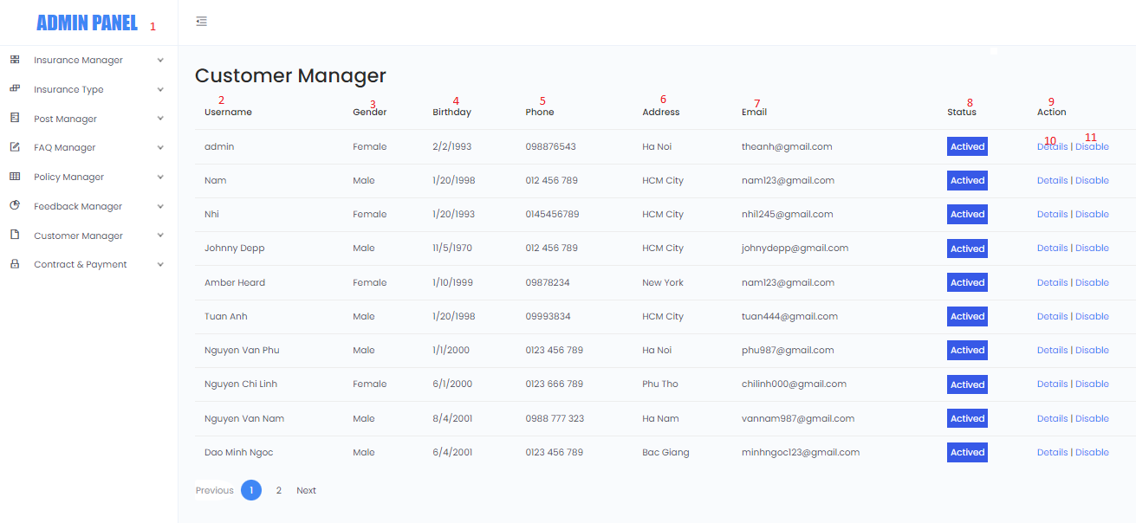

|  |  |  |  |  |  |  |  |  |  |  |  |
| --- | --- | --- | --- | --- | --- | --- | --- | --- | --- | --- | --- |
| **No** |  |  | **Name** |  | **Type** | **Validation** |  | **Event** |  | **Description** | **Status** |
|  |  |  |  |  |  |  |  |  |  |  |  |
| 1 |  |  | Navigation Bar |  | Hyperlink |  |  | Click |  | Choose and click to go to pages | Enable |
| 2 |  |  | Username |  | Text |  |  | Read Only |  | Customer Username | Enable |
| 3 |  |  | Gender |  | Text |  |  | Read Only |  | Customer Gender | Enable |
| 4 |  |  | Birthday |  | Text |  |  | Read Only |  | Customer Birthday | Enable |
| 5 |  |  | Phone |  | Text |  |  | Read Only |  | Customer Phone | Enable |
| 6 |  |  | Address |  | Text |  |  | Read Only |  | Customer Address | Enable |
| 7 |  |  | Email |  | Text |  |  | Read Only |  | Customer Email | Enable |
| 8 |  |  | Status |  | Text |  |  | Read Only |  | Customer Status | Enable |
| 9 |  |  | Action |  | Read |  |  | Read |  |  | Enable |
| 10 |  |  | Details |  | Hyperlink |  |  | Click |  | Navigate to details Customer page | Enable |
| 11 |  |  | Disable |  | Hyperlink |  |  | Click |  | Click to Disable or Active Customer | Enable |

***4.9*.2. Details Customer**

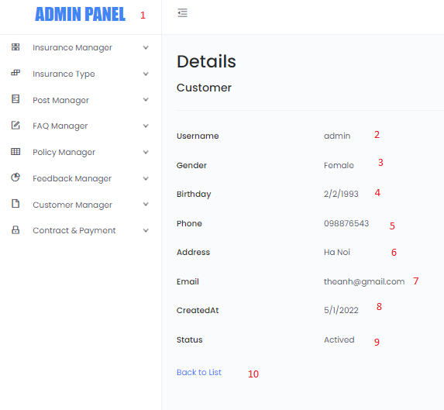

|  |  |  |  |  |  |  |  |  |  |  |  |
| --- | --- | --- | --- | --- | --- | --- | --- | --- | --- | --- | --- |
| **No** |  |  | **Name** |  | **Type** | **Validation** |  | **Event** |  | **Description** | **Status** |
|  |  |  |  |  |  |  |  |  |  |  |  |
| 1 |  |  | Navigation Bar |  | Hyperlink |  |  | Click |  | Choose and click to go to pages | Enable |
| 2 |  |  | Username |  | Text |  |  | Read Only |  | Customer Username | Enable |
| 3 |  |  | Gender |  | Text |  |  | Read Only |  | Customer Gender | Enable |
| 4 |  |  | Birthday |  | Text |  |  | Read Only |  | Customer Birthday | Enable |
| 5 |  |  | Phone |  | Text |  |  | Read Only |  | Customer Phone | Enable |
| 6 |  |  | Address |  | Text |  |  | Read Only |  | Customer Address | Enable |
| 7 |  |  | Email |  | Text |  |  | Read Only |  | Customer Email | Enable |
| 8 |  |  | Status |  | Text |  |  | Read Only |  | Customer Status | Enable |
| 9 |  |  | Action |  | Text |  |  | Read Only |  | Active or Disable | Enable |
| 10 |  |  | Back to list |  | Hyperlink |  |  | Click |  | Click and go back to List of Customer page | Enable |

**4.10 Contract and Payment**

***4.10.*1. List of Contract and Payment**

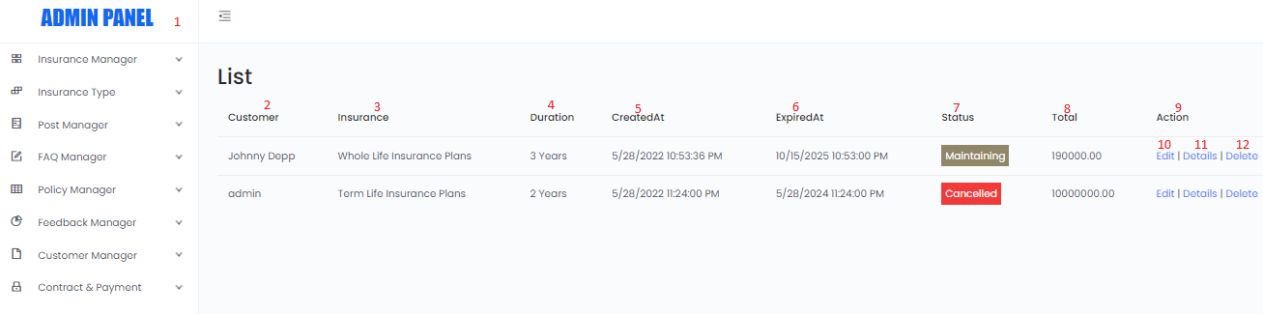

|  |  |  |  |  |  |  |  |  |  |  |  |
| --- | --- | --- | --- | --- | --- | --- | --- | --- | --- | --- | --- |
| **No** |  |  | **Name** |  | **Type** | **Validation** |  | **Event** |  | **Description** | **Status** |
|  |  |  |  |  |  |  |  |  |  |  |  |
| 1 |  |  | Navigation Bar |  | Hyperlink |  |  | Click |  | Choose and click to go to pages | Enable |
| 2 |  |  | Customer |  | Text |  |  | Read Only |  | Customer name | Enable |
| 3 |  |  | Insurance |  | Text |  |  | Read Only |  | Insurance type | Enable |
| 4 |  |  | Duration |  | Text |  |  | Read Only |  | Duration | Enable |
| 5 |  |  | Created At |  | Text |  |  | Read Only |  | Created Date | Enable |
| 6 |  |  | ExpriedAt |  | Text |  |  | Read Only |  | Expried Date | Enable |
| 7 |  |  | Status |  | Text |  |  | Read Only |  | Maintaning/Cancelled/Completed | Enable |
| 8 |  |  | Total |  | Text |  |  | Read Only |  | Total | Enable |
| 9 |  |  | Action |  | Read |  |  | Read |  |  | Enable |
| 10 |  |  | Edit |  | Hyperlink |  |  | Click |  | Navigate to Edit C&P page | Enable |
| 10 |  |  | Details |  | Hyperlink |  |  | Click |  | Navigate to details C&P page | Enable |
| 11 |  |  | Delete |  | Hyperlink |  |  | Click |  | Navigate to details C&P page | Enable |

***4.10.*2. Edit Contract and Payment**

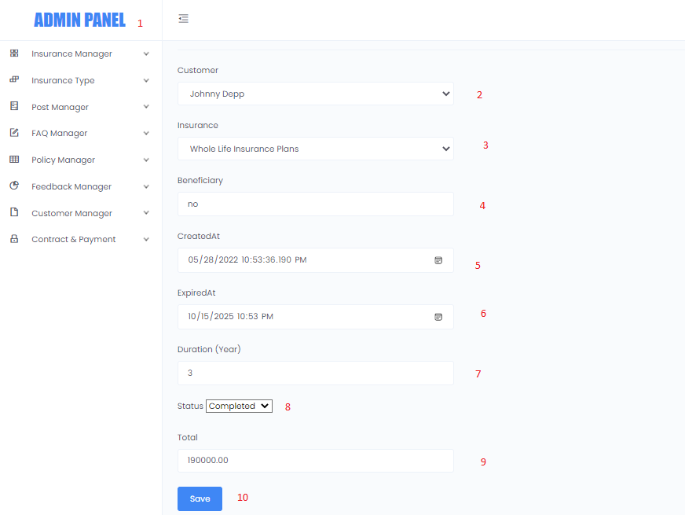

|  |  |  |  |  |  |  |  |  |  |  |  |
| --- | --- | --- | --- | --- | --- | --- | --- | --- | --- | --- | --- |
| **No** |  |  | **Name** |  | **Type** | **Validation** |  | **Event** |  | **Description** | **Status** |
|  |  |  |  |  |  |  |  |  |  |  |  |
| 1 |  |  | Navigation Bar |  | Hyperlink |  |  | Click |  | Choose and click to go to pages | Enable |
| 2 |  |  | Customer |  | Combo Box |  |  | Click |  | Choose Customer name | Enable |
| 3 |  |  | Insurance |  | Combo Box |  |  | Click |  | Choose Insurance type | Enable |
| 4 |  |  | Beneficiary |  | Text |  |  | Input |  | Input Duration | Enable |
| 5 |  |  | Created At |  | Text |  |  | Input |  | Choose Created Date | Enable |
| 6 |  |  | ExpriedAt |  | Text |  |  | Input |  | Choose Expried Date | Enable |
| 7 |  |  | Duration |  | Text |  |  | Input |  | Maintaning/Cancelled/Completed | Enable |
| 8 |  |  | Status |  | Combo Box |  |  | Cick |  | Choose Status | Enable |
| 9 |  |  | Total |  | Text |  |  | Input |  | Input Total | Enable |
| 10 |  |  | Save |  | Button |  |  | Input |  | Save C&P | Enable |

***4.10.*3. Details Contract and Payment**

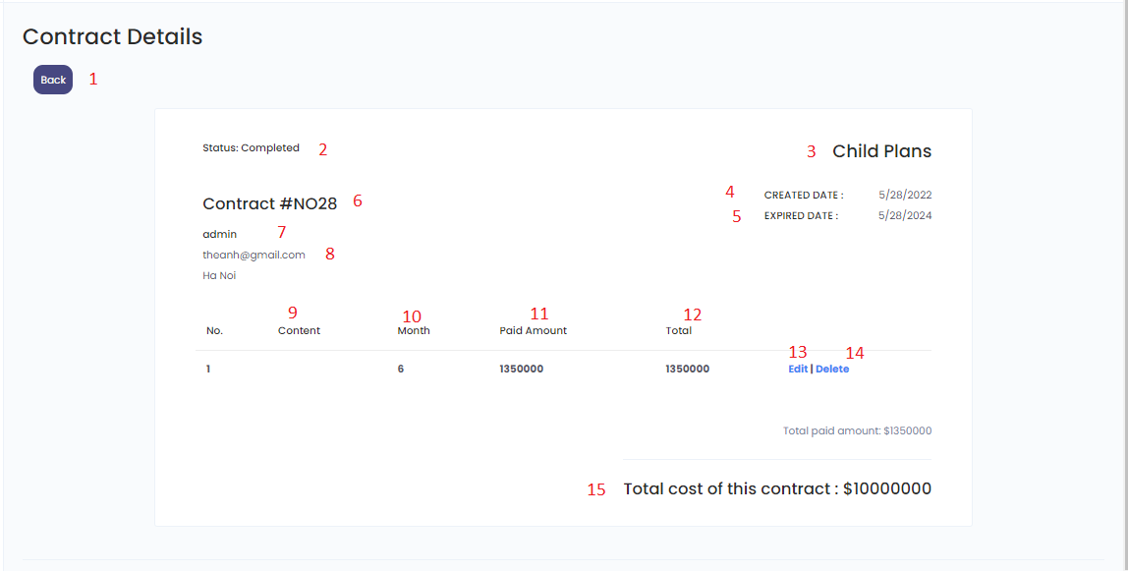

|  |  |  |  |  |  |  |  |  |  |  |  |
| --- | --- | --- | --- | --- | --- | --- | --- | --- | --- | --- | --- |
| **No** |  |  | **Name** |  | **Type** | **Validation** |  | **Event** |  | **Description** | **Status** |
|  |  |  |  |  |  |  |  |  |  |  |  |
| 1 |  |  | Back |  | Hyperlink |  |  | Click |  | click to go to C&P pages | Enable |
| 2 |  |  | Status |  | Text |  |  | Read Only |  | Status | Enable |
| 3 |  |  | Insurance |  | Text |  |  | Read Only |  | Insurance | Enable |
| 4 |  |  | Created At |  | Text |  |  | Read Only |  | Created At | Enable |
| 5 |  |  | ExpriedAt |  | Text |  |  | Read Only |  | ExpriedAt | Enable |
| 6 |  |  | Contract Id |  | Text |  |  | Read Only |  | Contract Id | Enable |
| 7 |  |  | Customer Name |  | Text |  |  | Read Only |  | Customer Name | Enable |
| 8 |  |  | Customer Email |  | Text |  |  | Read Only |  | Customer Email | Enable |
| 9 |  |  | Content |  | Text |  |  | Read Only |  | Content | Enable |
| 10 |  |  | Month |  | Text |  |  | Read Only |  | Month | Enable |
| 11 |  |  | Paid Amount |  | Text |  |  | Read Only |  | Paid Amount | Enable |
| 12 |  |  | Total |  | Text |  |  | Read Only |  | Total | Enable |
| 13 |  |  | Edit |  | Hyperlink |  |  | Click |  | Edit | Enable |
| 14 |  |  | Delete |  | Hyperlink |  |  | Click |  | Delete | Enable |
| 15 |  |  | Total cost of this contract |  | Hype Text rlink |  |  | Read Only |  | Total cost of this contract | Enable |

***4.10.*4. Delete Contract and Payment**

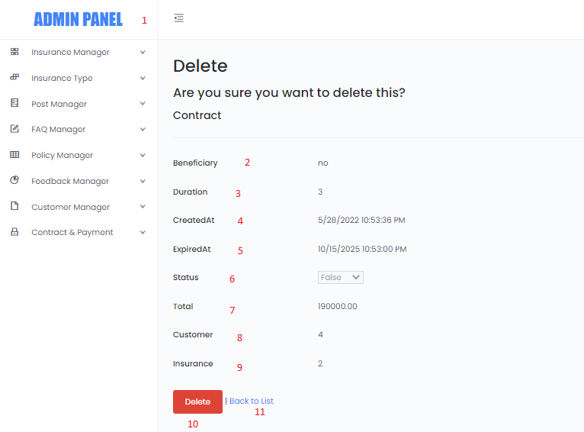

|  |  |  |  |  |  |  |  |  |  |  |  |
| --- | --- | --- | --- | --- | --- | --- | --- | --- | --- | --- | --- |
| **No** |  |  | **Name** |  | **Type** | **Validation** |  | **Event** |  | **Description** | **Status** |
|  |  |  |  |  |  |  |  |  |  |  |  |
| 1 |  |  | Navigation Bar |  | Hyperlink |  |  | Click |  | click to go to pages | Enable |
| 2 |  |  | Beneficary |  | Text |  |  | Read Only |  | Beneficary | Enable |
| 3 |  |  | Duration |  | Text |  |  | Read Only |  | Duration | Enable |
| 4 |  |  | Created At |  | Text |  |  | Read Only |  | Created At | Enable |
| 5 |  |  | ExpriedAt |  | Text |  |  | Read Only |  | ExpriedAt | Enable |
| 6 |  |  | Status |  | Text |  |  | Read Only |  | Status | Enable |
| 7 |  |  | Total |  | Text |  |  | Read Only |  | Total | Enable |
| 8 |  |  | CustomerId |  | Text |  |  | Read Only |  | CustomerId | Enable |
| 9 |  |  | InsuranceId |  | Text |  |  | Read Only |  | InsuranceId | Enable |
| 10 |  |  | Delete |  | Button |  |  | Read Only |  | Delete C&P | Enable |
| 11 |  |  | Back to List |  | Hyperlink |  |  | Read Only |  | click to go to C&P pages | Enable |

# TASK SHEET REVIEW 3

|  |  |  |  |  |  |  |  |
| --- | --- | --- | --- | --- | --- | --- | --- |
| **Project Ref. No.:**  **eP/Advertisement** **Portal Management** **System/01** | | **Project Title:** | **Activity Plan** **Prepared** **By:** | **Date of Preparation of Activity Plan:** | | | |
| **Sr.No.** | **Task** | **Actual Start** **Date** | **Actual** **Days** | **Team** **Mate** **Names** | **Status** |
| 1 | Database Design Diagram | Insurance Online | Nam | 14/05/2022 | 17 | Hieu | Completed |
| 2 | Database Structure | 14/05/2022 | 17 | Hieu | Completed |
| **3** | **GUI Design Front End** | 14/05/2022 | 17 |  | Completed |
| 3.1 |  |  |  |  |  |
| **4** | **GUI Design Back End** | 14/05/2022 | 17 | Hieu | Completed |
| 4.1 | Admin Login Page | 14/05/2022 | 17 | Hieu | Completed |
| 4.2 | Account Admin Setting and Log out | 14/05/2022 | 17 | Hieu | Completed |
| 4.3 | Insurance Manage | 14/05/2022 | 17 | Hieu | Completed |
| 4.4 | Insurance Type Manage | 14/05/2022 | 17 | Hieu | Completed |
| 4.5 | Post Manage | 14/05/2022 | 17 | Hieu | Completed |
| 4.6 | FAQs Manager | 14/05/2022 | 17 | Hieu | Completed |
| 4.7 | Policy Manage | 14/05/2022 | 17 | Hieu | Completed |
| 4.8 | Feeback Manager | 14/05/2022 | 17 | Hieu | Completed |
| 4.9 | Customer Manager | 14/05/2022 | 17 | Hieu | Completed |
| 4.10 | Contract and Payment | 14/05/2022 | 17 | Hieu | Completed |
| 5 | Tasksheet Review | 14/05/2022 | 17 | Hieu | Completed |

|  |  |
| --- | --- |
| **Date: 31/05/2020** | |
| Signature of Instructor:  **Hoang Duc Quang** | Signature of Team Leader:  **Do Thanh Nam** |